Chile-Argentina-Brazil 2025
15 days/14 nights

Chile + Patagonia + Argentina + Foz do Iguacu + Rio 2025
NH Cuidad Santiago 4* + Costaustralis 4* + Hotel Rochester Calafate 4* + 474 Hotel Buenos Aires 4* + Viale Cataratas 4*+Arena Leme 4* + services | 1 pax | 2 pax |  | 3pax
 | SGL | SGL | DBL | SGL | DBL | TPL
 | $ 8008 | $ 6496 | $ 4750 | $ 6219 | $ 4472 | $ 4322

Day 1: Santiago de Chile
Upon arrival in the international airport of Santiago de Chile you will be transferred to your hotel. Santiago de Chile has very interesting historical, residential and business districts.

Day 2: Santiago de Chile
Breakfast in the hotel.
Today you will go on a city tour to the most interesting sights in Santiago, beginning with the
historic downtown district, visiting Main Square, Cathedral, Post Office Headquarters, and Santiago City Hall. Take a walk through the historic center and you will see the Plaza de Armas with a monument dedicated to the founder of the city - Pedro de Valdivia, as well as the monument called Freedom America; and a monument to the first Chilean Cardinal - Jose Maria Caro. We will see the Government House “La Moneda” and also go to the Santa Lucia Hill, a small hill in the centre of Santiago which is the remnant of a volcano 15 million years old. Afterward, we will take you to East Santiago, where you may appreciate modern buildings, with offices, apartments, shopping centers and restaurants. Additionally you can have a tour and wine tasting to the wineries in the Maipo Valley. The price per person 230 USD (minimum 2 pax)
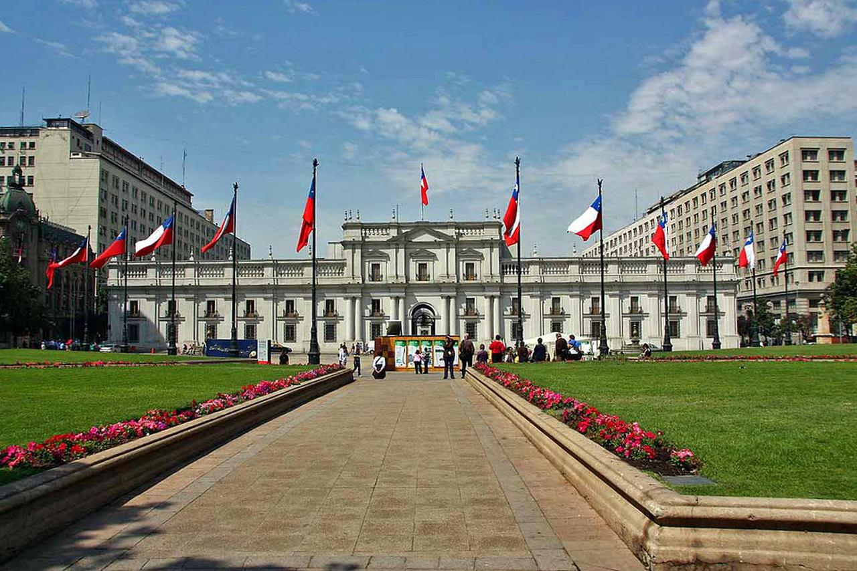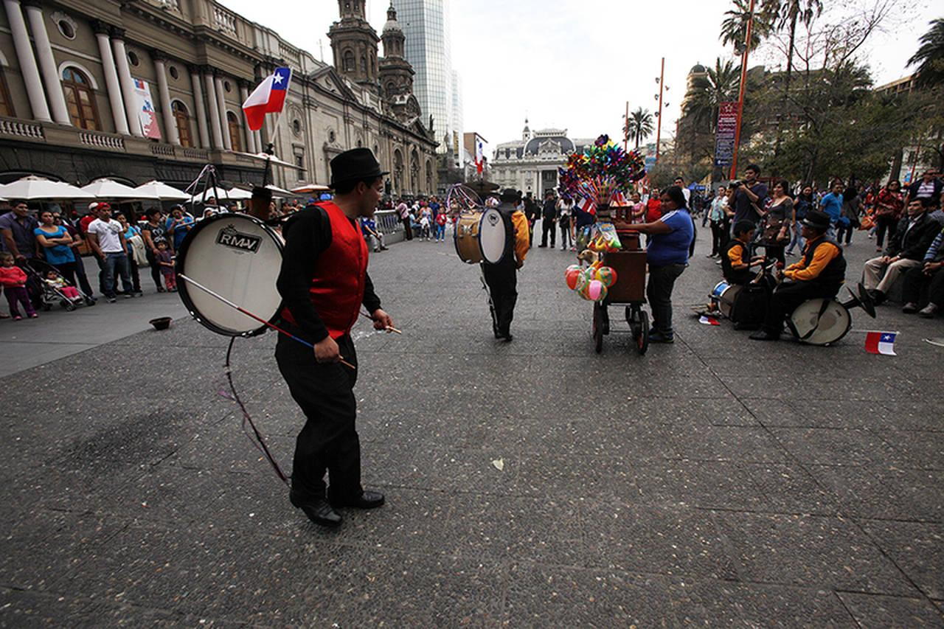

Day 3: Santiago de Chile – Puerto Natales
Transfer to the airport for your flight to Punta Arenas . Transfer to the bus station to drive to Puerto Natales. Upon arrival you will be transferred to the hotel.

Day 4: Puerto Natales
Breakfast in the hotel. Soaring almost vertically more than 2000m above the Patagonian steppe, the granite pillars of Torres del Paine (Towers of Paine) dominate the landscape of what may be South America’s finest national park. Before its creation in 1959, the park was part of a large sheep estancia, and it’s still recovering from nearly a century of overexploitation of its pastures, forests and wildlife. Most people visit the park for its one greatest hit but, once here, realize that there are other attractions with equal wow power. We’re talking about azure lakes, trails that meander through emerald forests, roaring rivers you&#39;ll cross on rickety bridges and one big, radiant blue glacier. Variety spans from the vast openness of the steppe to rugged mountain terrain topped by looming peaks.
.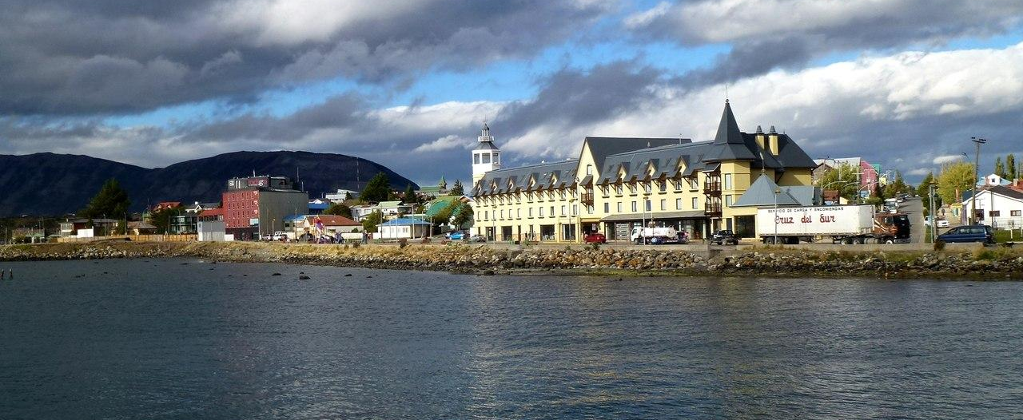
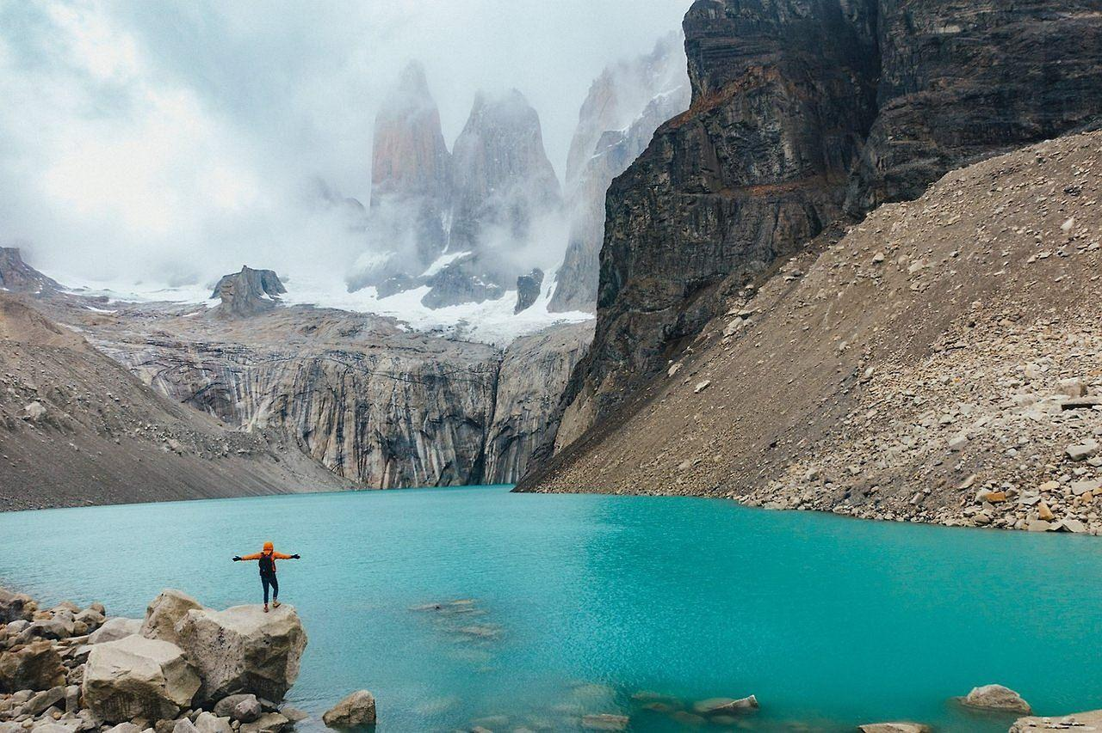
Part of Unesco Biosphere Reserve system since 1978, the park is home to flocks of ostrichlike rhea (known locally as the ñandú), Andean condor, flamingo and many other bird species. Its star success in conservation is undoubtedly the guanaco, which grazes the open steppes where pumas cannot approach undetected. After more than a decade of effective protection from poachers, these large and growing herds don’t even flinch when humans or vehicles approach.
A full day tour visiting the amazing national park of Torres del Paine including the Milodon Cave, located at the Benitez hill, 25 km from Puerto Natales, where in 1895 a skeleton of a Sable-tooth tiger, American Horse and Huge Lazy known as Milodon were discovered. We will walk for around 30 minutes in this cave observing the stalactite formations and the Milodon imitation copyAfter this we will continue our way to the national park Torres del Paine where we can see the most varied landscapes starting from a Maggelan forest and ending with the Patagonian Plain with its strong winds and dry air. Upon arrival at the park the scenery changes drastically, the national park containing over 242.000 hectares, we can now see tens of lakes with birds and enormous mountains. The lakes water is blue and crystal clear, the waterfalls and peaks covered with ice are among the typical landscapes of this park. A 15 min walk will take up to Salto Grande, a waterfall connecting 2 lakes, Nordenskhold and Peoe. We will return along a beautiful road, passing by the Serrano River
and the Toro and Porteno lakes. Overnight at hotel.

Day 5: Puerto Natales - El Calafate
Transfer to the bus station and shared bus to Calafate. Private Transfer in to your hotel.
El Calafate claims its livelihood from a single tourist attraction, the spectacular Glaciar Perito Moreno in Parque Nacional Los Glaciares, It can be devided into two parts the north and the southern part, with El Calafate on Lago Argentino the gateway. The park is the second largest in Argentina, extending some 170 km along the Chilean frontier and covering some 759,000 hectares. It was declared a World Heritage region by UNESCO in 1987. Some 40% of the park is covered by giant ice fields, with 47 major glaciers of which 13 flow east descending into the park to feed the two big lakes, Lake Viedma in the north and Lago Argentino in the south. There are also about 190 smaller glaciers that are not connected to the ice fields. All together a great spectacle you have to see.
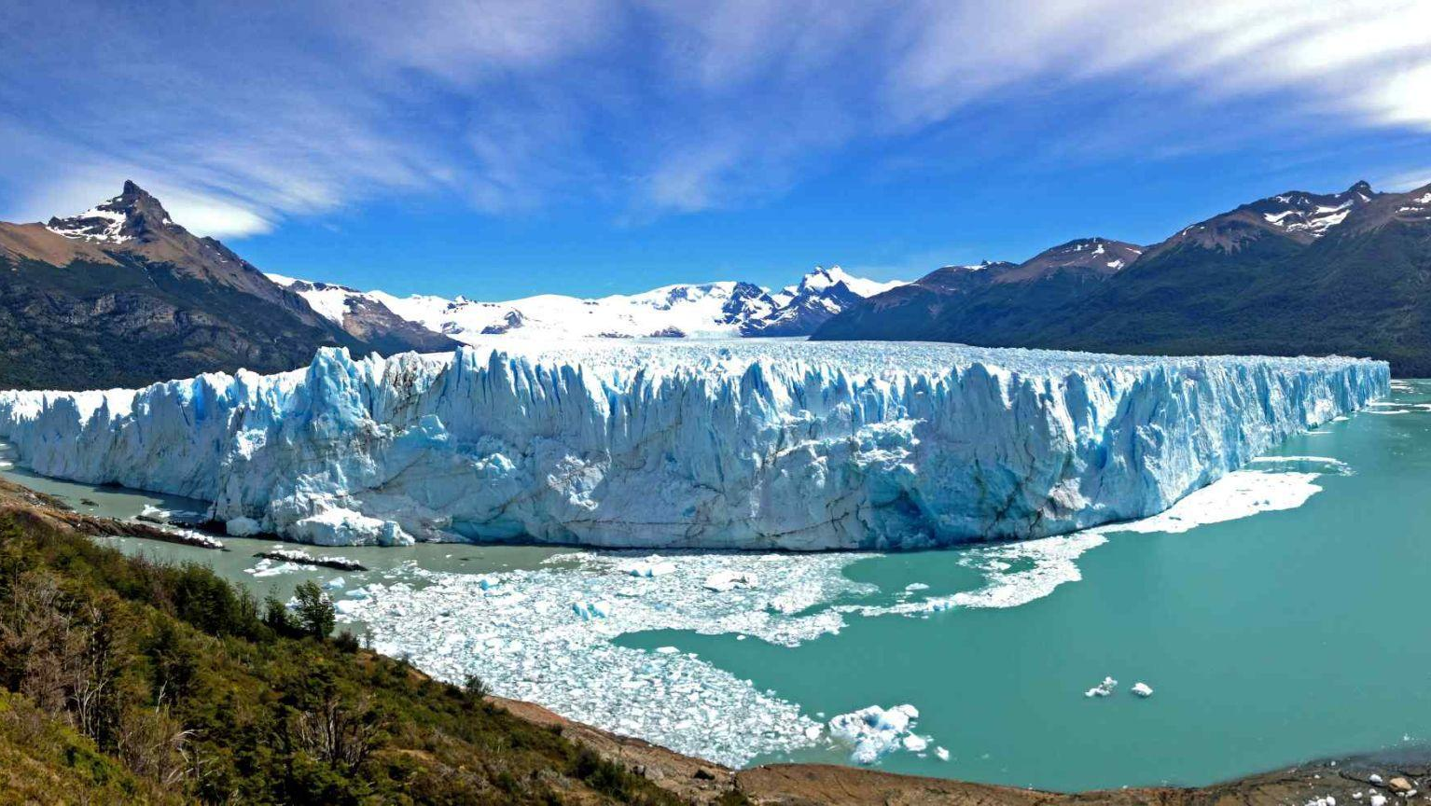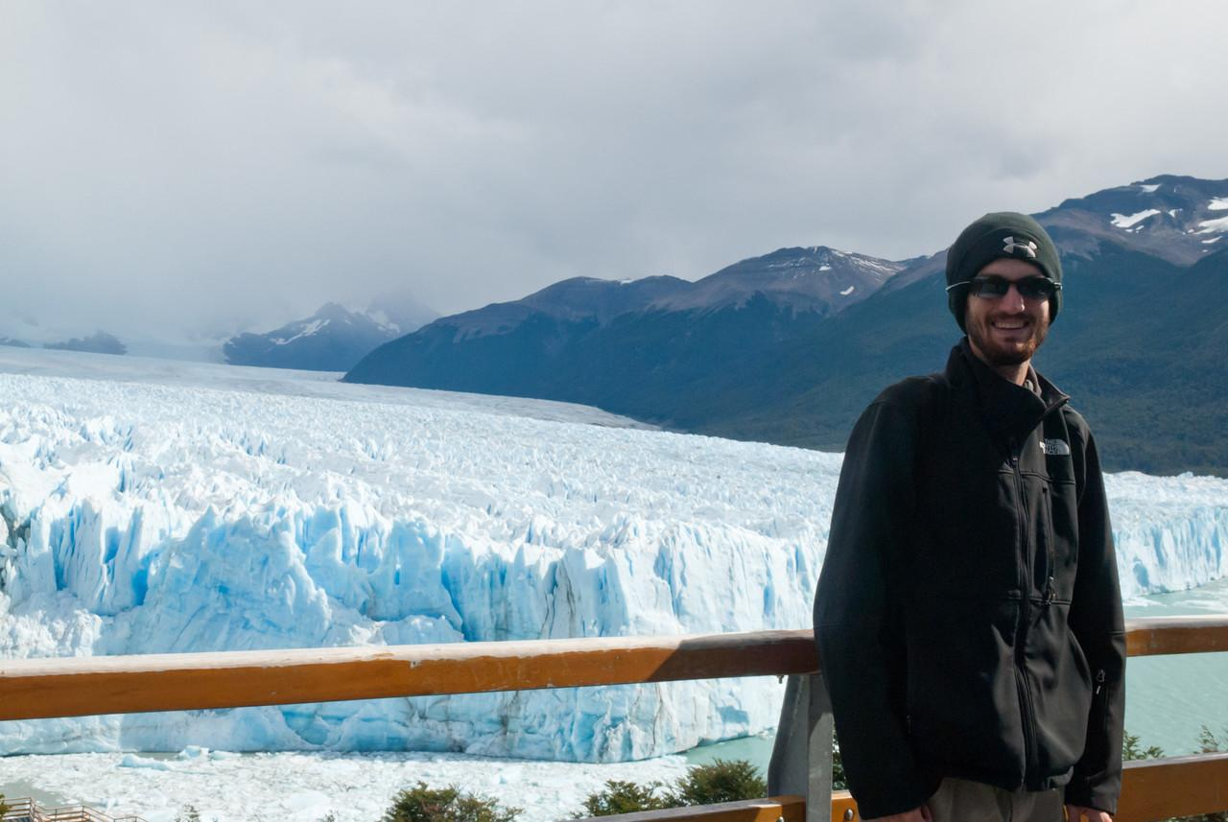

Day 6: El Calafate
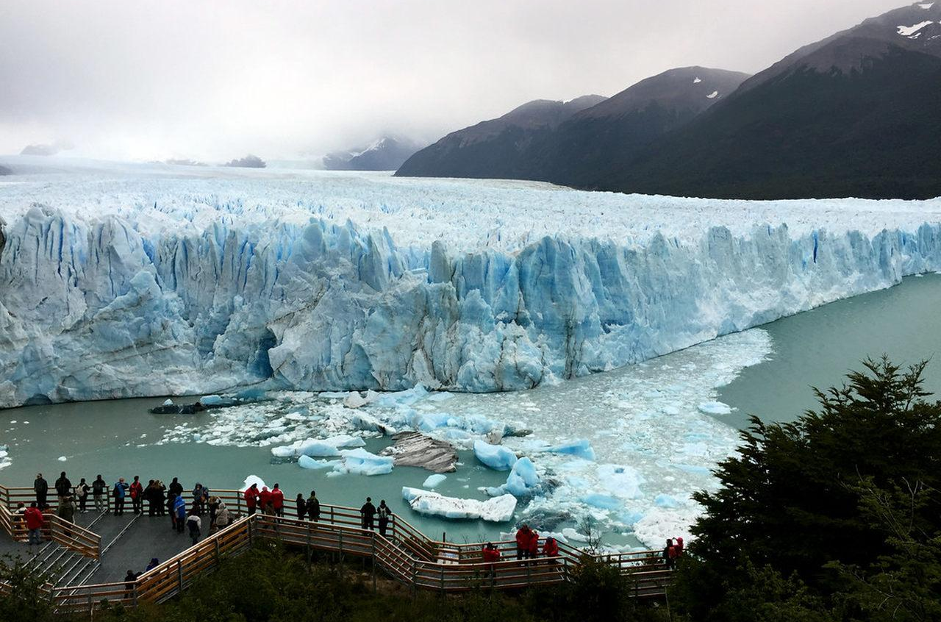
Breakfast in the hotel. Excursion to the Perito Moreno Glacier in Los Glaciares National Park (in a group with an English-speaking guide). The National park has been declared as Mankind Heritage by UNESCO. Those glaciers that named it (about 47) show us a 10 thousand-year-old world: cold and wild. The most famous one is Perito Moreno Glacier in the southwestern end of Argentine Lake at 80 km away from El Calafate. This glacier is so-called due to a great Argentinian explorer from last century and is one of the few glaciers that is still moving in the world. That is why it has become one of the most spectacular natural shows in South America. From time to time its 60-m-high snout releases some ice walls as huge as buildings that fall into Rico Bend or Canal de los Témpanos (Ice floes Channel) and then they continue sailing along the channel to the main area of the lake. However, that is not all. The glacier, while moving forward, comes closer to the Magallanes Peninsula, in the opposite lake bank as well as footbridge and viewpoint area. This cycle takes from 4 to 6 years and it eventually separates the lake into two areas. Rico Bend is dammed up and it increases about 35 m over its average level. Its water slowly pierces its way through the glacier snout until it makes it fall down. This show is breathtaking.

Day 7: El Calafate - Buenos Aires
Breakfast in the hotel. Flight to Buenos Aires. Prior to your arrival you will be transferred to the hotel.

Day 8: Buenos Aires
Breakfast in the hotel. City Tour Buenos Aires. This panoramic tour will take you through the highlights of South America’s most European and cosmopolitan city. We’ll drive along 9 de Julio Avenue where the renowned Colón Theater and the Obelisk, symbols of our city, are located. We’ll visit Plaza de Mayo, surrounded by important historic buildings like the Casa Rosada, the Cathedral and the City Hall. We’ll also visit Plaza San Martin, Alvear and Plaza del Congreso. The tour will drive us along
the old fashion Avenida de Mayo and the dynamic Avenida Corrientes. Explore neighborhoods filled with colors and history, like La Boca and San Telmo, and the sumptuous neighborhoods of Palermo, Recoleta and the modern Puerto Madero, a busy gastronomic and entertainment area.
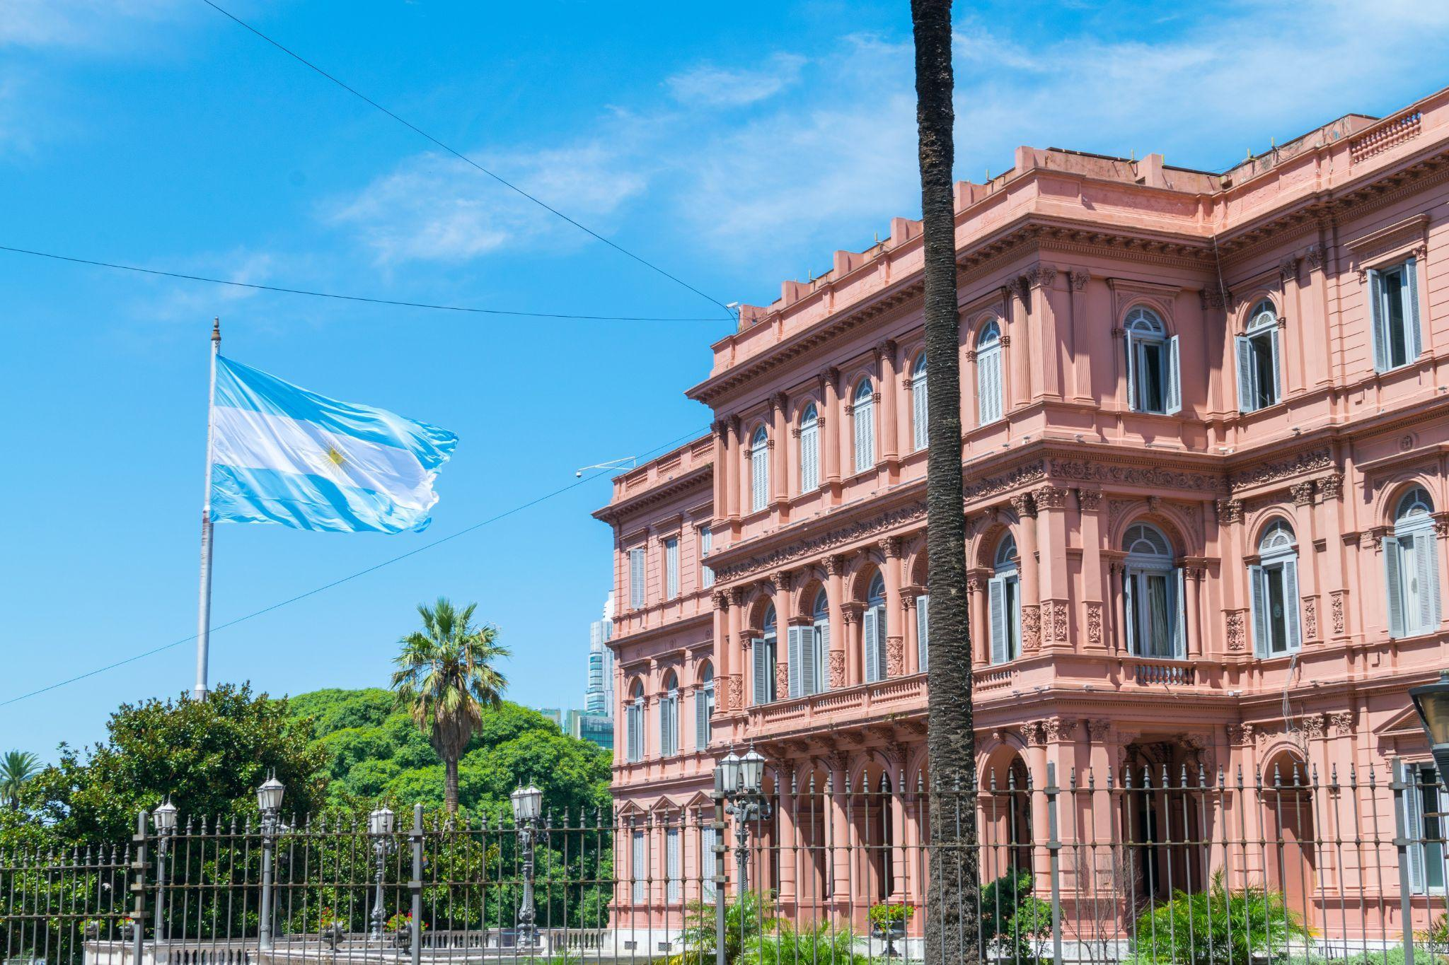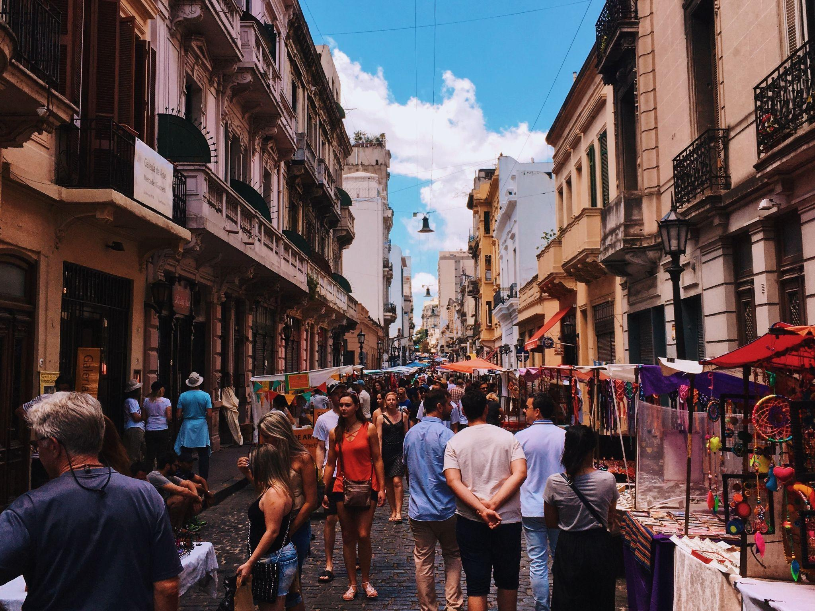
In the evening enjoy an amazing Tango Show and Dinner.
Tango is still alive. A good way of penetrating its spirit is visiting one of the restaurants that offers tango shows of an excellent level, to enjoy tango´s sensual magnetism taken to the stage by some of the best dancers, singers and musicians in Buenos Aires!
After a delicious dinner, you will follow a spectacular presentation of acclaimed popular and sensuous Tango, performed by the world’s best. It is the music of Buenos Aires par excellence. Tango is felt in the air of the city, as humidity!
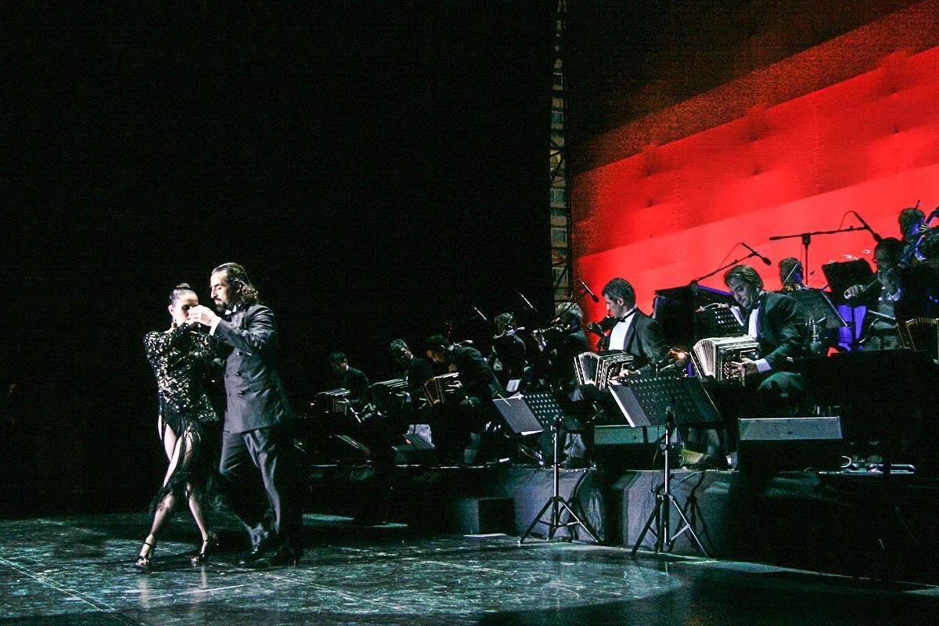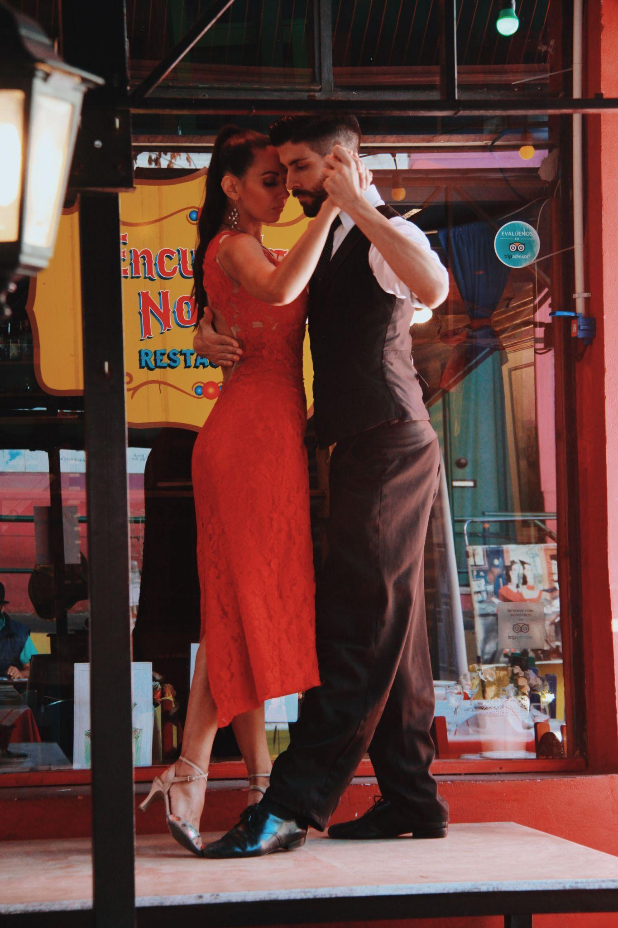

Day 9: Buenos Aires
Breakfast at hotel.Free time for additional excursions or discovery the city.
Additional excursions:

- Full day tour to Fiesta Gaucho (group tour with English guide/USD 320 P/P)
Upon arrival you will be received with a glass of Argentine wine and will be invited to taste empanadas, typical small cakes with various options like meat, cheese, ham, chicken or vegetables. Whilst you enjoy horseback riding or just a relaxing stroll in the countryside and after visiting the ‘gaucho’ museum, a superb BBQ of premium beef will be prepared for lunchtime. After lunch an impressive folkloric dance and cowboys show will be presented before returning to Buenos Aires.
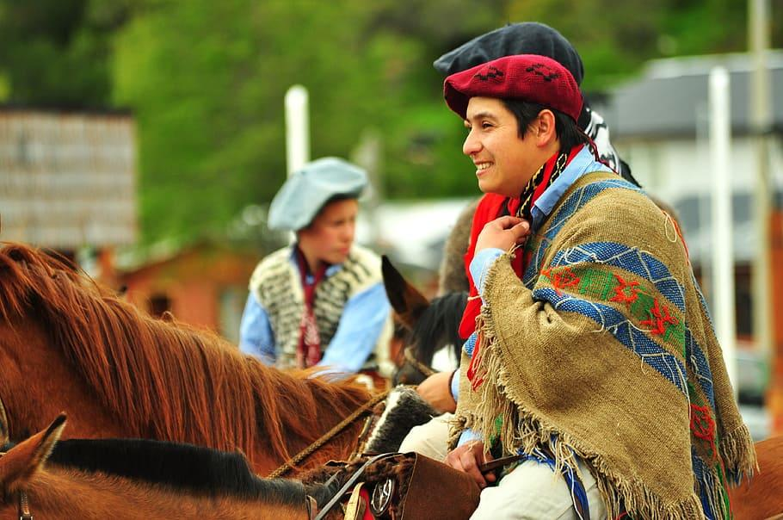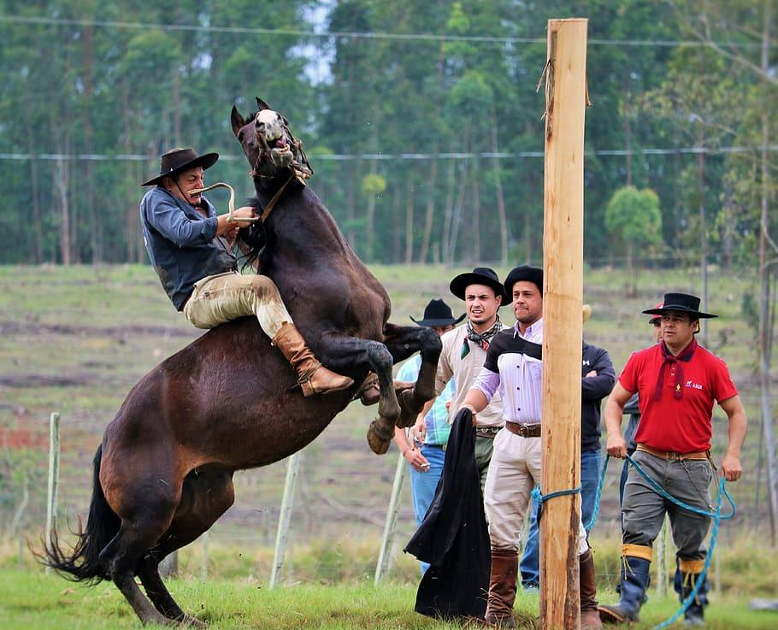

2)Montevideo (Uruguay)
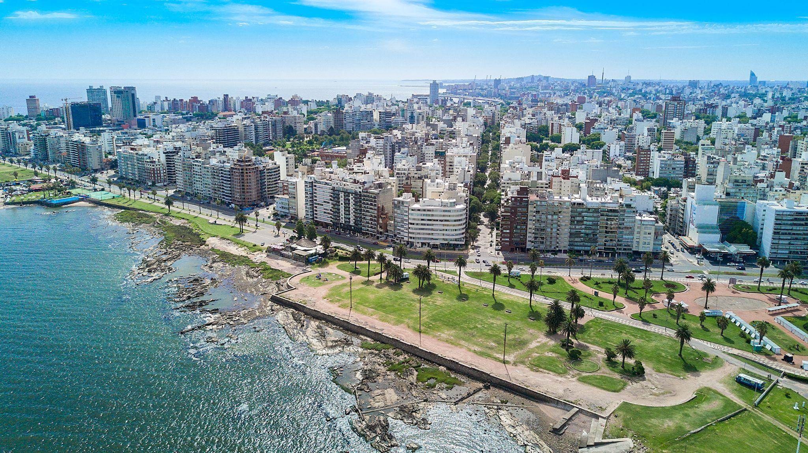
Full day tour in Montevideo from Buenos Aires (group tou/ USD 500P/P r). A driver will take you to the port of Buenos Aires, where you will pick up a ferry boat to Montevideo city by Colonia del Sacramento. Upon arrival at Montevideo, a guide will be waiting for you for a panoramic city tour. This walk covers the most important points of the city’s Old Town and new residential neighborhoods. Inside the old city is visited: Independence Square, where the old Citadel Gate (Montevideo was a fortified city), then comes Matrix Square where the Montevideo Cathedral, The Cabildo, Plaza Zabala and Teatro Solis, all these pieces of history of the city. Then its the Palacio Salvo, first high-rise building in the city, Plaza de El Entrevero, continuing to the Legislative Palace where the Uruguayan Parliament meets. The tour continues visiting the following suburbs: The Prado, with its ancient history which houses the Government House, the Parque Batlle, which runs the Estadio Centenario, La Carreta Monument and the residential neighborhoods of Carrasco and Pocitos. The return is by the coast to the center of Montevideo. At the end of the tour, you will get back to port to take a ferry boat back to Buenos Aires. Upon arrival, only a driver will take you to your hotel. Duration: 8 hours

3) Tigre Tour and Northern Zone (USD 100 P/P)
We will leave Buenos Aires city heading for the town of Tigre, one hour away, where we will board a tourist boat to navigate along the Delta and its islands. The life of the isleños (people who live on the islands of the Delta) is very special. We will learn about their customs, culture and ways of life. On the way back to Buenos Aires city we will drive by the elegant residences of the well-off, located in the northern suburbs, and the San Isidro neighborhood. Additionally, you will also get a glimpse of the Presidential Residence (Quinta de Olivos) as we drive by it.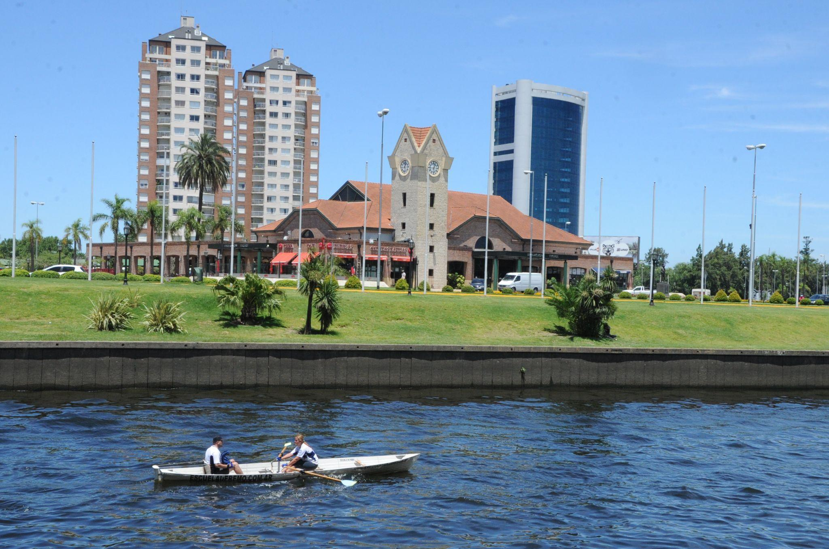

Day 10: Buenos Aires – Foz do Iguazu
Transfer to the airport. Flight to Iguazu. After your arrival you will go on a tour to the Argetinian side of the falls. The Argentinean side is very different from the Brazilian one; there are the three trails leading you through the nature in the park:
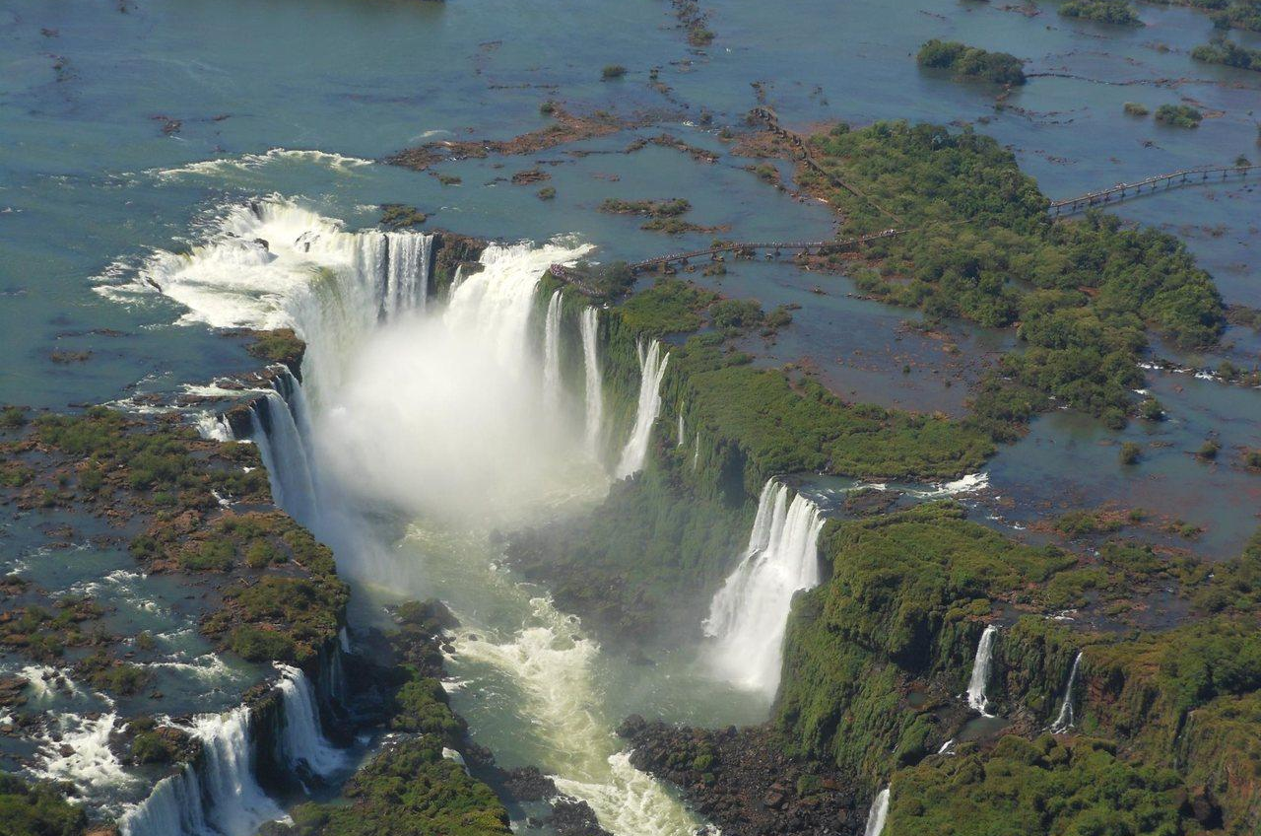
The Lower Circuit: At a length of 1,700 meters, runways venture into the lush jungle to take direct contact with the breaking of the Dos Hermanas, Chico and Ramirez. Walking down a runway you can be at the foot of a huge seawall which is the fall of Salto Bosetti and you will enjoy the steep falls in the Saltos Alvar Nuñez, Elenita and Lanusse. The Upper Circuit: a walk of 1,300 meters, elevated runways will take you on the fall line of several major jumps, reaching the edge thereof. It provides an overview of the whole area from a greater height. The Devil’s Throat: Accessed through the Rainforest with the Ecological Train arriving at the Devil’s Throat Station. From there, after a 1,000 meters walk, you will reach the enormous Devil’s Throat.
You will walk around next to the falls to have a close look of the falls. You can feel the strength of the water and enjoy the 55.500 hectares of natural beauty!
Day 11: Foz do Iguazu - Rio de Janeiro
After breakfast your guide picks you up for a visit of the Brazilian side of the falls. Today you will visit the Brazilian site of the magnificent Iguaçu Falls following the walkways which border the canyon of the Iguassu River. It is possible to observe hundreds of small waterfalls until ending up in front of the magnificent Devils Throat, the strongest and mightiest of all falls. The splashes coming from the falling water make you FEEL the falls grandeur and cover the sky with thousands of rainbows.
After the excursion you will have transfer to the airport and flight to Rio de Janeiro. Transfer to the hotel.
*Additionally you can take excursions:
Macuco Safari (135 U$/person)
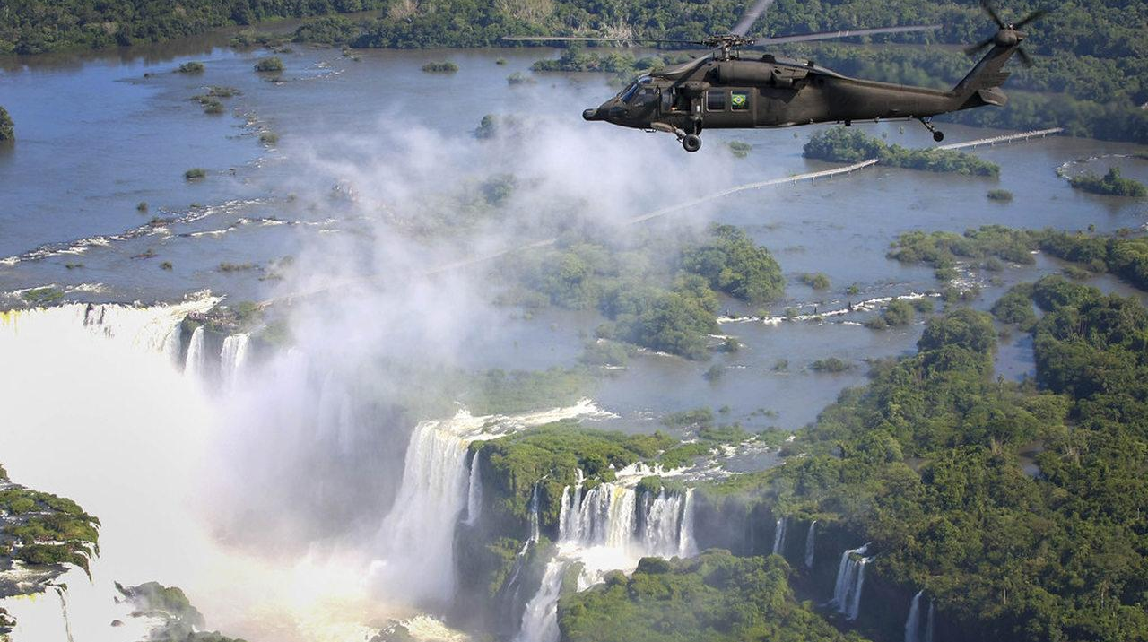
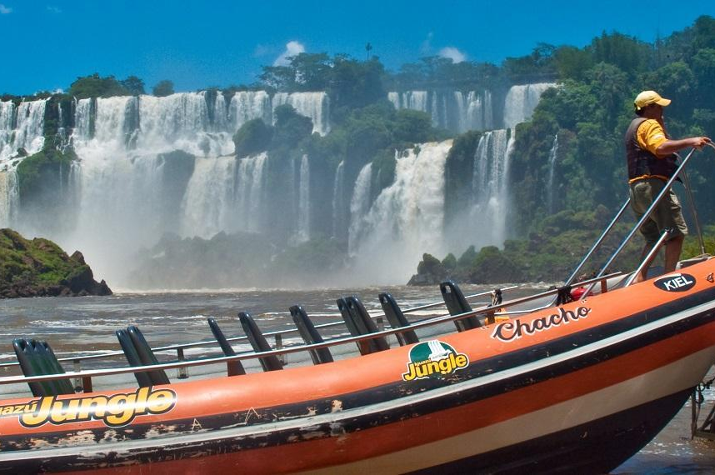
You will go on a tour through the jungle, and then get to a wonderful boat ride. In the jungle you will ride in an open jeep for about 3 kilometers, accompanied by a guide who will tell you a lot of interesting things about the ecology of the region. Then you will go on foot to the banks of the Iguazu River, from where they will take you by motor boat close to the waterfalls. You are expected by splashes and rainbows, the sea of delight and unique photos.

Over the waterfall by helicopter! (170 U$/person)
You will see the power and beauty of waterfalls from a bird's-eye view! This is an amazing and unforgettable sight!

Bird Park (65 U$/person)

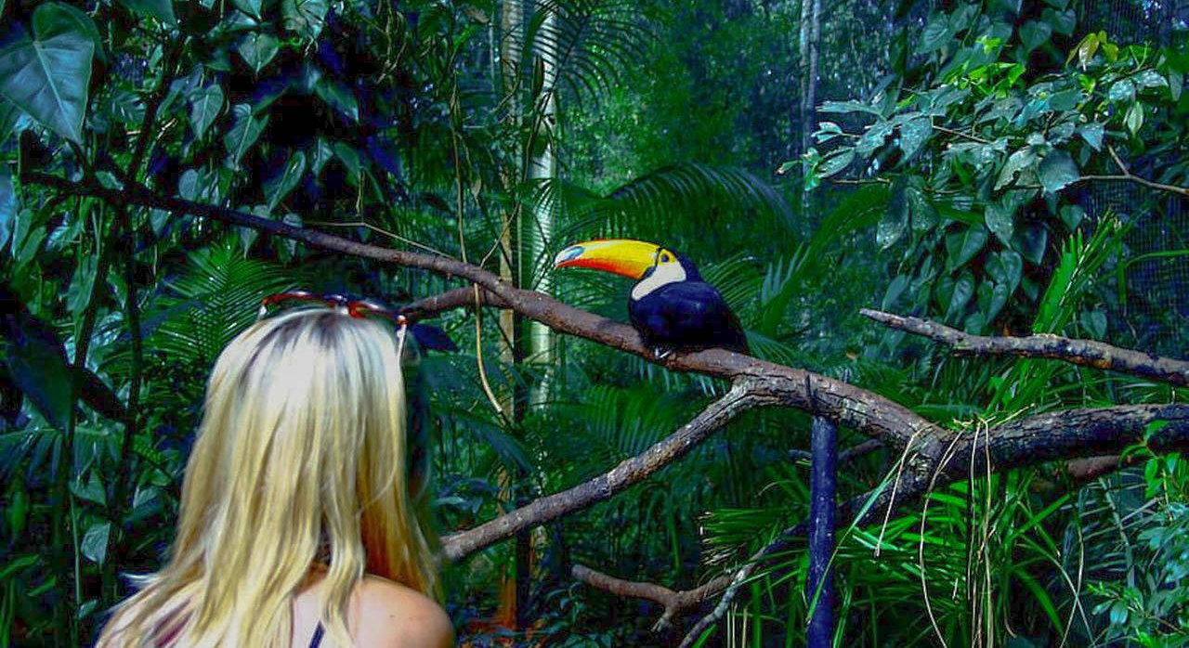
One of the city’s most important tourist attractions, the Parque das Aves is located next to the entrance of the Iguaçu National Park. Inside the Parque das Aves you will be in a unique universe, surrounded by birds from all over Brazil and the world. There are more than 800 birds from 200 different species preserved in 16.5 hectares of spectacular Atlantic Rainforest in which you can walk with your friends and family when visiting Foz do Iguassu. The Parque das Aves has three immersion aviaries and a butterfly house, in which you can enter and be side by side with toucans, scarlet ibises, macaws, jays and thrushes. Over the course of this extraordinary tour you’ll also find harpy eagles, owls, parrots and even reptiles such as alligators and the anaconda. By the end, you can relax in the restaurant with an exclusive view across the lake of flamingos or take as a souvenir a picture holding a macaw or next to a boa constrictor. Have the best experience with the natural world of Foz do Iguaçu and bring your friends and family to the Parque das Aves for an unforgettable adventure.

Day 12: Rio de Janeiro
After breakfast you will discover Rio with our guide.
Rio de Janeiro – its green hills, blue sky, rocky mountains, beautiful bays, islands, beautiful beaches. The second most populous city in Brazil and one of the most beautiful cities in the world. Hotels located on the most famous black-and-white tiled promenade of Copacabana, Leblon, Ipanema. The dreams come true in this city! If you arrive before dark, it will be possible to see Rio de Janeiro’s green hills, blue sky, rocky mountains, and palm trees on both sides of beautiful bays. By day or night you can walk at the famous black-and-white tiled promenade of Copacabana, Leblon, Ipanema.
Maybe you will want to see and feel the lush life of the city during the night, or if you want to be alone with yourself, then, for this there is always a corner somewhere in between the palm trees, sand and ocean waves.
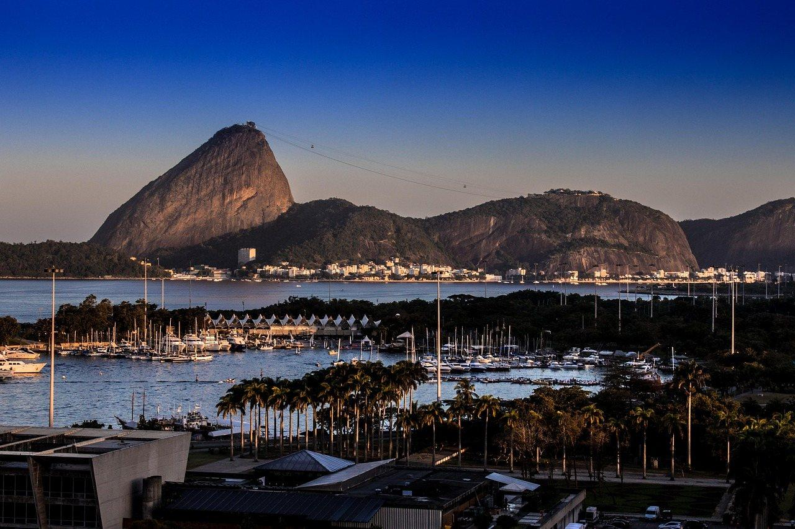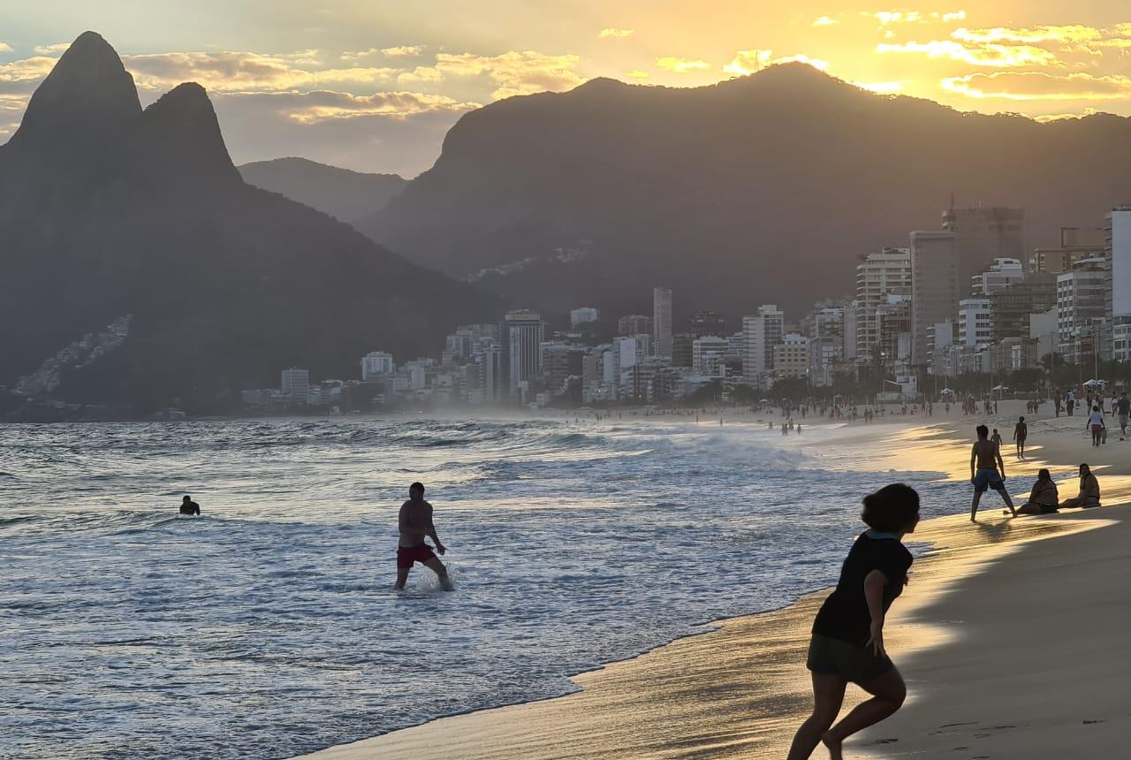

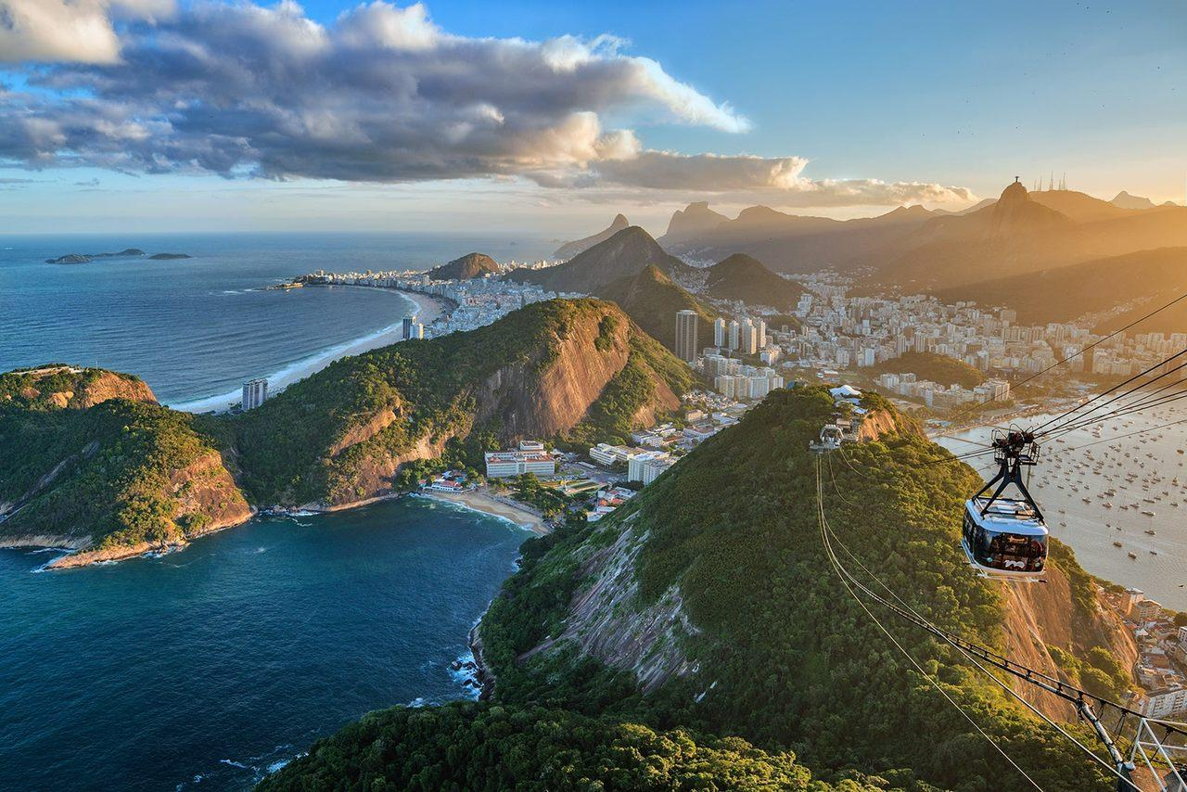
Excursion to the Sugar Loaf (4 hours) - A magnificent cable car ride will take you up to Urca Mountain, the stop off between ground level and Sugarloaf. From there you can enjoy a smooth cocktail or sample some of Brazil’s many signature dishes. Once arriving to the top of Sugarloaf mountain you will see the captivating beauty of Rio from a different angle. To your left you can see Copacabana beach stretching off into the distance, and on the horizon the faint outlines of Two Brothers and Gávea mountains. Below you is the quaint and intimate Red Beach, while to your right you can see across Guanabara Bay to Niterói and, closer in, Rio’s Botafogo and central neighborhoods, with the unmistakable silhouette of Christ the Saviour casting its eternal gaze over the city. This trip is essential to gain a different perspective on Rio, and to truly understand its beauty.

Day 13: Rio de Janeiro
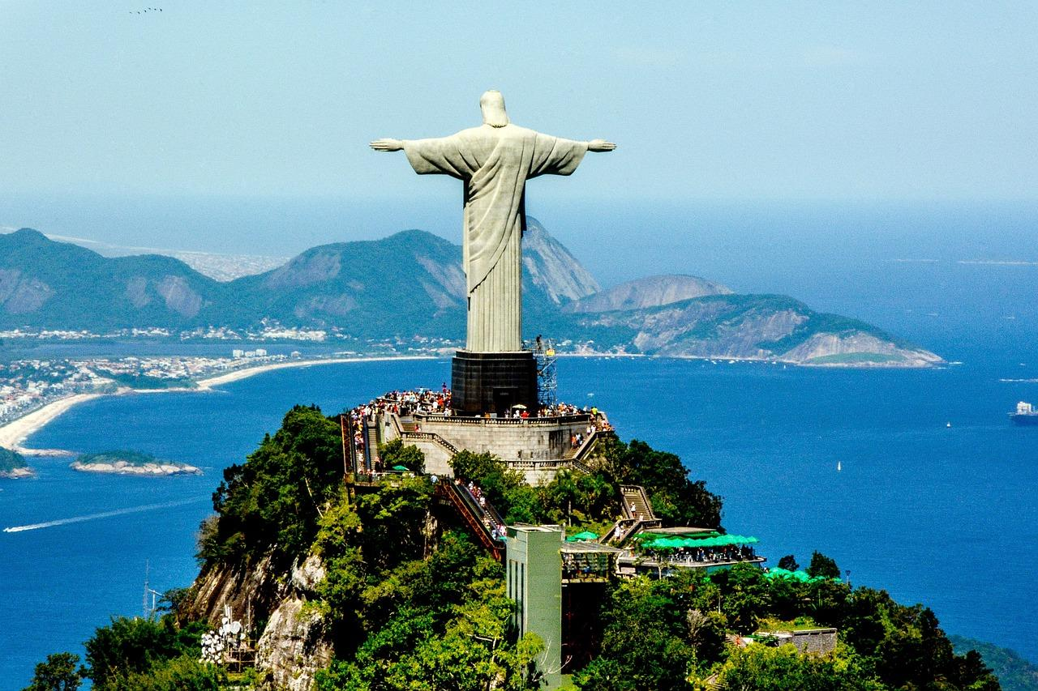
After breakfast, we will discover the historical part of Rio. Then you have the chance to go on a half-day excursion to the Corcovado Mountain. Arriving at the station, the environmentally friendly train will take us through the jungle to the top of Corcovado. On both sides of the railway you will have spectacular views of Tijuca forest, inhabited by monkeys and other exotic animals and birds. On top of Corcovado, at an altitude of 700 m above sea level, you will stand in front of the symbol of Rio de Janeiro- Statue of Christ the Savior (38m) that was built in 1931. From top of Corcovado, you have a breathtaking panoramic view of the city and its surroundings like the Bridge Niteroi, Guanabara Bay, the Botanical Garden, the Maracana stadium and the Sugar Loaf.

Day 14: Rio de Janeiro
Breakfast at the hotel. Free day for walks or additional excursions.

Botanical Garden
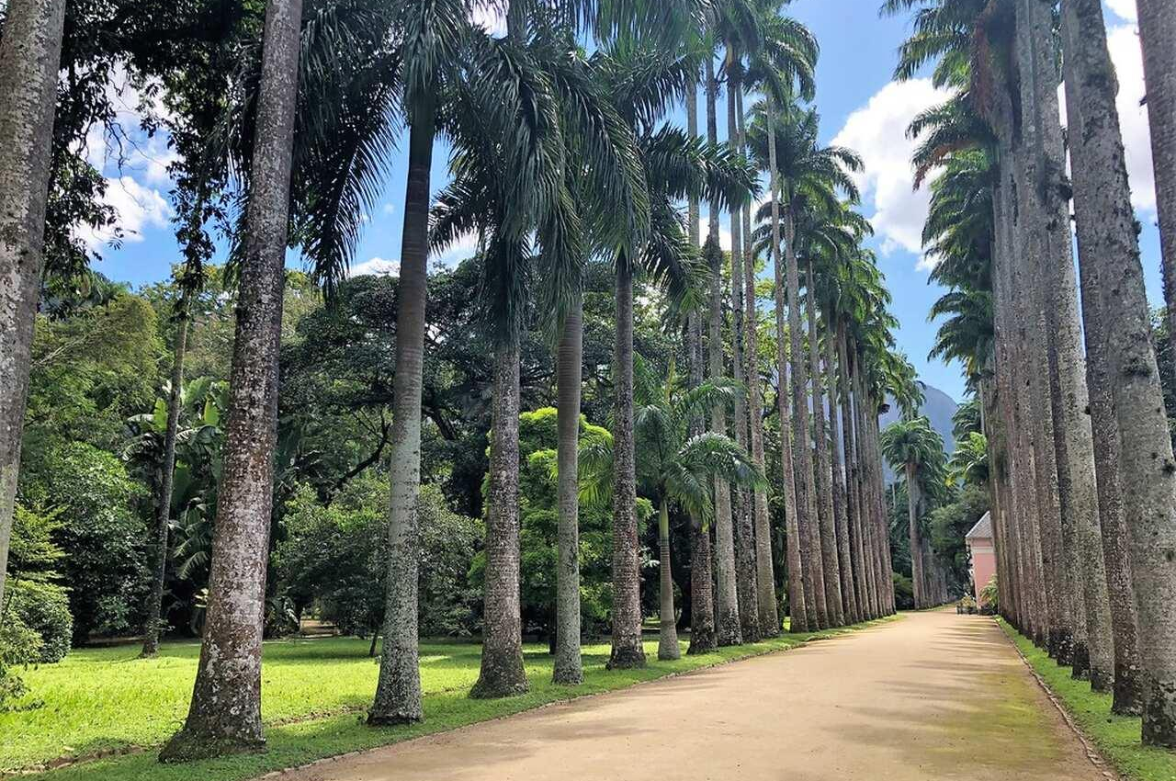
The Rio de Janeiro Botanical Gardens is a magnificent 137 hectare garden over 200 years old featuring over 7000 different species of plants. Some of the most beautiful exotic plants in the world such as orchids, bromeliads, cacti and giant bamboo are on display here, in the shadow of the Corcovado mountain. The botanical pond, featuring the giant waterlilies, is a favourite spot for the local wildlife, particularly capivara families which can be seen playing in the shallow waters. Duration: 4 hours

Royal Petropolis
You will go on a guided trip to Petropolis, located high in the mountains 60 km away from Rio de Janeiro.
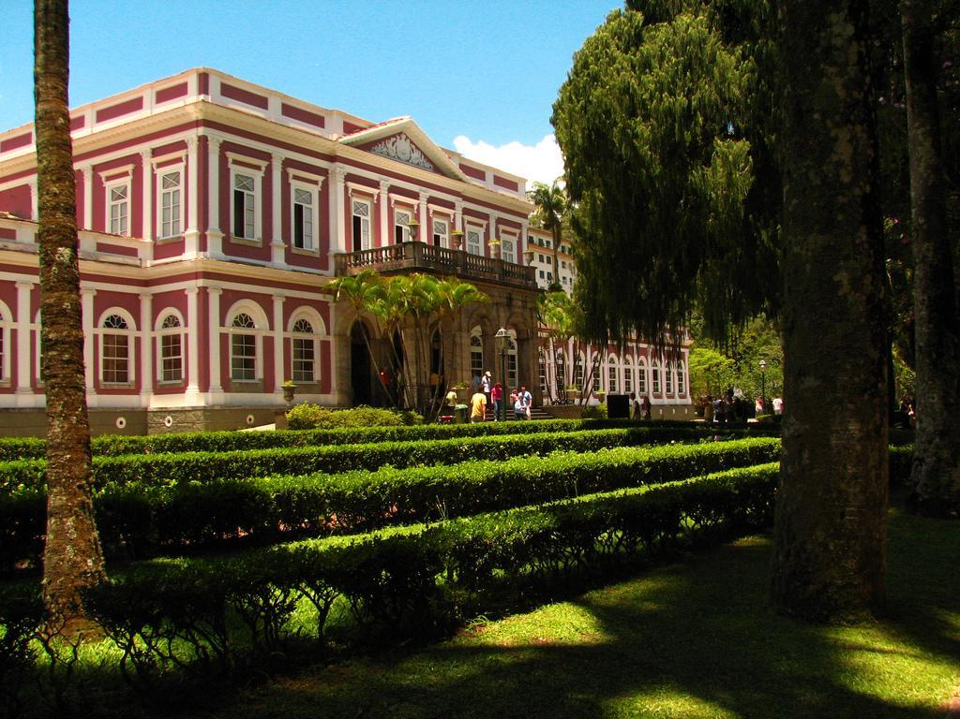
Petropolis is one of the most important Brazilian historic towns located in the mountains 60 km away from Rio de Janeiro. Pedro II bought this land in 1830 to build a summer palace and bring there his daughter who could not stand the hot climate of Rio de Janeiro due to her health conditions. The european founders of the city built many constructions there, the beautiful examples of German style architecture. The Royal palace still preserves many objects of Royal furniture and the Royal family’s objects that are now exposed in the museum. Here you can find unique jewelry works; for example, a golden crown decorated with diamonds and pearls. Together with our guide you will visit the Gothic Cathedral where Princess Isabel, King Pedro II and his wife are buried. Then you will visit the Royal museum. Afterwards you will leave to the state of Minas Gerais and spend the night in Ouro Preto.

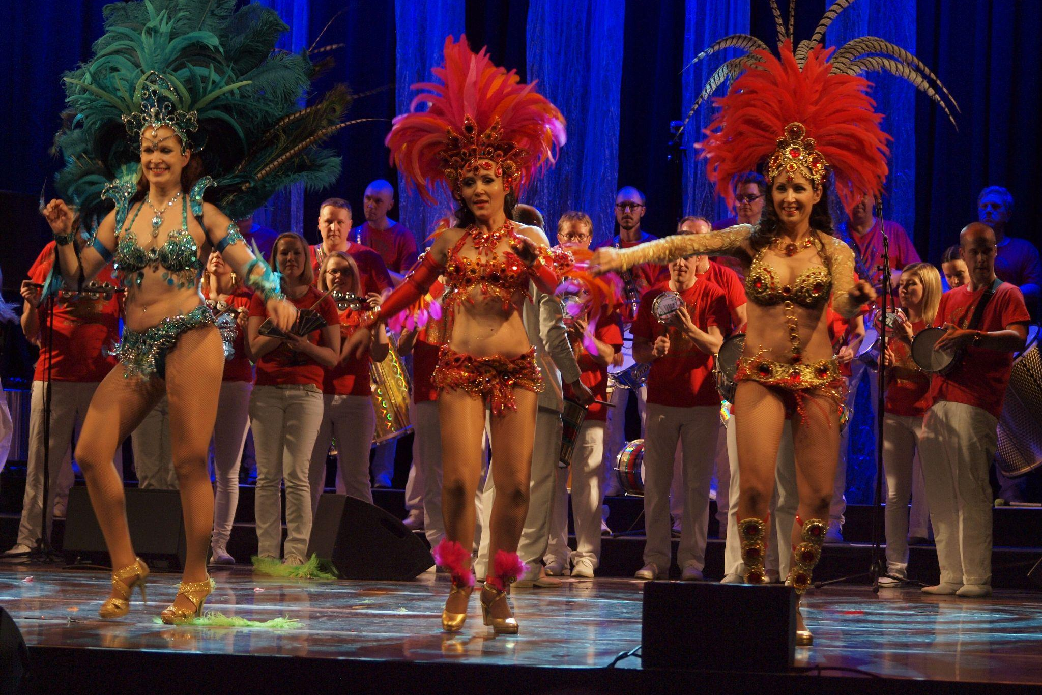
Rio Night: Samba Show
Samba Show Rio provides an unforgettable night of Brazilian music and dance. You will experience authentic Latin culture as world class performers sing and dance to the sounds of samba and capoeira. Dinner is provided during the show, after which you will be taken back to your hotel.
Duration: 4 hours

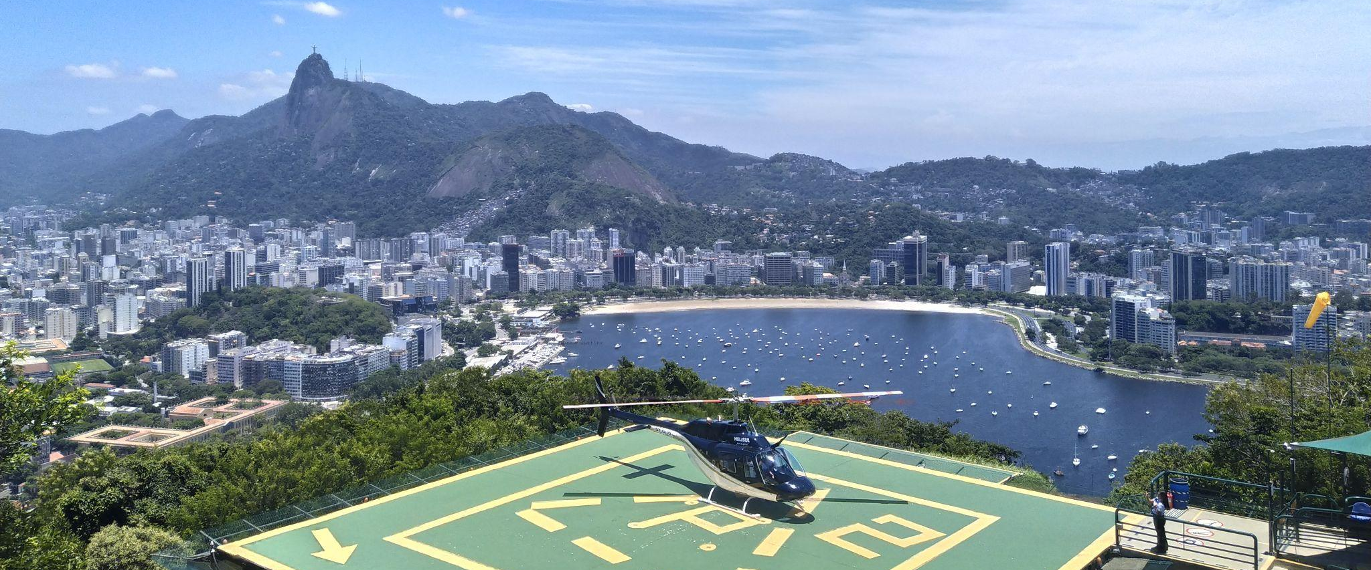
Helicopter flight over Rio
This special trip begins at Sugarloaf mountain or Lagoa. Rio is always best seen from up on high, and you will get an unobstructed view of the Marvellous City from the skies, with the Christ the Redeemer statue, Sugarloaf mountain, Two Brothers mountain, and the golden curves of Copacabana and Ipanema down below. Flight duration: 8-9 minutes

Day 15: Rio de Janeiro
Breakfast in the hotel. Transfer with a driver to Rio de Janeiro Airport for an international flight.

End of services.

The price of the program includes:
✔ Accommodation in 4* standard category hotels with breakfast
✔ All transfers according to the program with a driver
✔ Guide services throughout the program
✔ Excursions according to the program
✔ Meals according to the program

The price of the program does not include:
o International flight
o Domestic flights
o Additional excursions
o Food and drinks not specified in the program
o Tips
o Laundry service

