Chile 2025
Santiago – Atacama Desert - Torres del Paine
7 days / 6 nights

Santiago shines with the glass facades of a modern city on the shores of the Pacific Ocean, while majestic Andes mountain ranges stretch endlessly from north to south. The Atacama Desert is the driest and oldest desert in the world. Torres del Paine National Park is located in the mountain ranges of Torres del Paine and Cuernos del Paine. The park's landscape features mountains, glaciers, rivers, lakes, tundra, and forests. The three granite peaks are the park's main attraction.

The price of the program per pax in $ USD:

Hotels: | 1 SNG | 1/2 DBL | 1/3 TRL | 1/4 QUAD
NH Cuidad Santiago (2n) + Hotel Kimal (2n) + Noi Indigo Patagonia (2n) | $7,275 | $3,904 | $3,206 | $2,578

Day 1: Santiago
Arrival at the airport and transfer to the hotel in Santiago. After check-in, a half-day city tour awaits you. A guided tour of Santiago includes a visit to the historic city center, Plaza de Armas square, the Post Office building, Municipality, Government House "La Moneda," and Cerro Santa Lucía. The tour continues to the east of the city, exploring its modern residential quarters and new commercial districts. Return to the hotel.

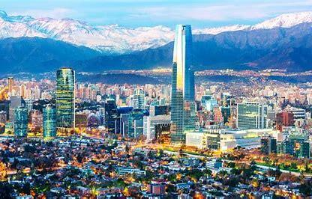

Day 2: Santiago – Calama

Breakfast at the hotel. Transfer from the hotel in Santiago to the airport for a flight to Calama. Upon arrival, meet at Calama airport and transfer (regular) to San Pedro de Atacama. A half-day excursion to the Moon Valley awaits you. Located a few kilometers from San Pedro de Atacama, the Valley of the Moon, amid sharp rocks and unusual contours of the Cordillera de la Sal, is a geological wonder. During the tour, enjoy the fascinating landscape forms that make you feel like you're walking on the lunar surface. In the afternoon, witness the breathtaking views of the Andean mountain range and its volcanoes. As the sunset approaches, golden and red tones will appear on the desert, creating a truly captivating panorama. Transfer and accommodation at the hotel. Included: entrance fee to Moon Valley, cocktail.

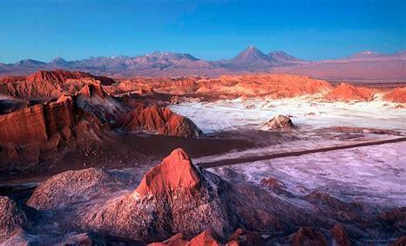

Day 3: San Pedro de Atacama
After breakfast at the hotel, embark on a full-day excursion to the salt flat of the Atacama Desert, high-altitude plateau lagoons, and Socaire. Visit the high-altitude plateau lagoons Miscanti and Miniques. Lunch in Socaire – a village located 100 km southeast of San Pedro de Atacama. Journey to the Atacama salt flat, Salar de Atacama, to visit the Chaxa lagoon and the Flamingo National Reserve, where you will observe three of the six different flamingo species existing in the world. Continue to the town of Toconao, visiting the San Lucas church and the Campanario tower. Return to San Pedro. Included: entrance fee to Chaxa and high-altitude plateau lagoons, lunch.

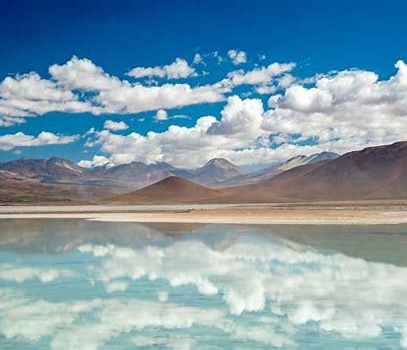

Day 4: San Pedro de Atacama
Breakfast at the hotel. Tatio Geysers and Machuca (regular half-day tour). Today, visit the impressive fumaroles of the Tatio geysers. "Tatio" in the language of the indigenous people who once inhabited these slopes means "Crying Old Man." The geysers are located at an altitude of over 4000 meters above sea level. Hot water fountains appear at sunrise from 06:00 to 07:00. The trip starts early in the morning to witness the sunrise in one of the most important geothermal fields in the world: the Tatio Geysers. There are over 70 fumaroles, from which jets of steam emerge, forming pools of boiling water. The most amazing part of the day is the sunrise, the contrast between the bright blue sky and the clean steam of the geysers. In the center of this impressive natural landscape next to the Andes, enjoy a refreshing breakfast to warm up, as the temperature in the mornings is -2 °C below zero. Then visit a rural pool, where you can enjoy a bath in the Cordillera's hot springs. On the way back to San Pedro de Atacama, observe the beauty of the landscape, its valleys, local flora and fauna, highlighting charismatic vicuñas and viscachas. Afterward, stop in Machuca, an Atacama village consisting of a couple of houses made of adobe, straw, and cactus wood, where its inhabitants engage in tourism and offer products from Andean craftsmen and typical cuisine, such as llama meat, sopaipillas, and empanadas. Also, visit the beautiful church of San Santiago, the patron saint of the town, and a small bofedal, where flamingos, ducks, and other birds live. Included: entrance fee to Tatio geysers, group transfer to Calama, and flight to Santiago.

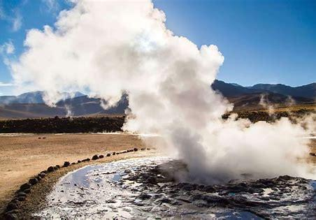

Day 5: Santiago - Puerto Natales
Breakfast at the hotel. Then, transfer from the hotel to the airport for a flight to Puerto Natales. Arrival in Puerto Natales, meet and transfer to the hotel. Check-in and rest at the chosen hotel.

Day 6: Torres del Paine Torres del Paine & Milodon Cave (regular full-day tour).
At 07:00, you will be picked up from the hotel to go to the natural monument, Milodon Cave, where a prehistoric mammal lived 12,000 years ago. Continue the tour and enjoy incredible views of Laguna Soffia, Cordillera Prat, Lake Porteño, Cerro Mesa, Lake Toro. At Mirador Grey, make a stop and then move to the village of Rio Serrano. Continue our hike around Lake Grey, through the Lenga forest, to see the lake's shore, where you can see icebergs, broken off from the glacier. Lunch at a local restaurant. Visit the viewpoint of Lake Pehoe and Salto Grande, from where we will take a pleasant walk to the 18-meter high waterfall. Visit the viewpoint of Lake Nordenskjold, Laguna Amarga, and Mirador Sarmiento. Return to Puerto Natales, arriving at 18:45.
Included: entrance fee to Torres del Paine and Cueva del Milodon, lunch.

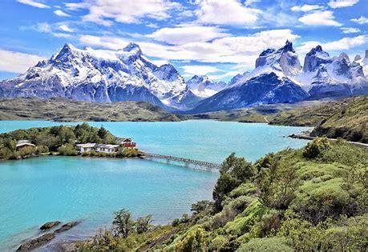

Day 7: Puerto Natales - Santiago
Breakfast at the hotel. Private transfer from the hotel in Puerto Natales to the airport for your flight to Santiago, arriving in time for your departure home. Flights: from $650 (depends on the moment of booking)

Included:
- Accommodation in specified or similar hotels, based on breakfast

Day 1-2 | NH Cuidad Santiago: Standard Room, BB
Day 2-4 | Hotel Kimal: Standard room, BB
Day 4-5 | NH Cuidad Santiago: Standard Room, BB
Day 5-7 | Noi Indigo Patagonia: Standard room, BB

- Meals as per the program
- Entrance tickets
- Airport-hotel-airport transfers
- All mentioned excursions, including transportation
- Guided tours in groups
- 24/7 assistance throughout the trip

Not included:
- Airfare
- Meals not specified in the program
- Travel insurance
- Tips (recommended tips are $5 USD for half-day tours and $10 USD for full-day tours)
- Bank fees (fees for incoming bank transfers or a 5% fee for credit card payments)

