Congress in Rio de Janeiro- base 45 pax

Itinerary:

Day 1: Transfer in airport to Hotel
Arrival day in Rio de Janeiro! A driver will be waiting for you at the international airport of Rio de Janeiro to transfer you to your hotel. The rest of the day is free to discover the city or enjoy your first day at the beautiful beaches of Rio de Janeiro.
Transfer airport-hotel for 45 seater is 500 U$ bus + guide

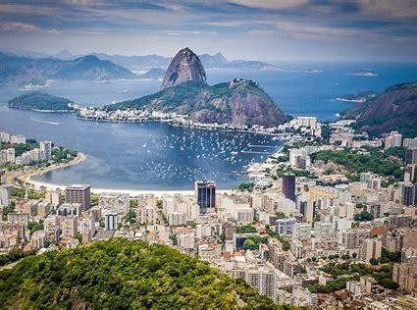

Rio de Janeiro and its green hills, blue sky, beautiful bays, islands and marvelous beaches. It is the second biggest city in Brazil (after Sao Paulo) and, certainly, one of the most beautiful cities in the world! Beach hotels are situated along the whole perimeter of Guanabara Bay and, if you are staying in one of these hotels, the beauties of Rio de Janeiro are open for you all the time. Blue ocean water will call you to the beach. The most popular beaches - Copacabana, Ipanema and Leblon, are famous for their black and white tiled promenade. From early morning to late in the night you can see people playing soccer and volleyball on the golden sand of the beaches. For those who prefer active holidays, Rio offers opportunities to practice almost any sport: golf, tennis, surfing, rafting, diving, delta flight and many others. Numerous open cafeterias on the beach will offer you refreshing coconut water, freshly squeezed juices and other drinks. You can also see presentations of local musicians on the beach playing all kinds of music.
Welcome drink

transfer to Dinner at Fogo do Chao -Dinner and transfer at 80 $/person
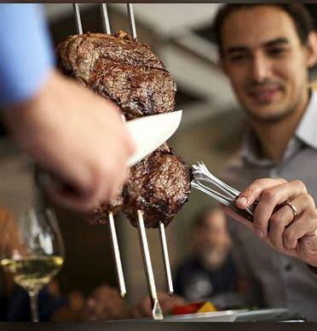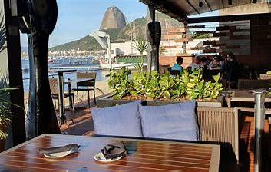

Day 2- congress in the morning after breakfast

After the congress you have the chance to go on a half-day excursion to the Corcovado Mountain. Arriving at the station, the environmentally friendly train will take us through the jungle to the top of Corcovado. On both sides of the railway you will have spectacular views of Tijuca forest, inhabited by monkeys and other exotic animals and birds. On top of Corcovado, at an altitude of 700 m above sea level, you will stand in front of the symbol of Rio de Janeiro- Statue of Christ the Savior (38m) that was built in 1931. From top of Corcovado, you have a breathtaking panoramic view of the city and its surroundings like the Bridge Niteroi, Guanabara Bay, the Botanical Garden, the Maracana stadium and the Sugar Loaf. Lunch at Confeteria Colombo Tour with entrance fee and lunch 143 U$/person

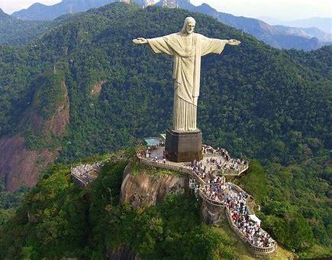
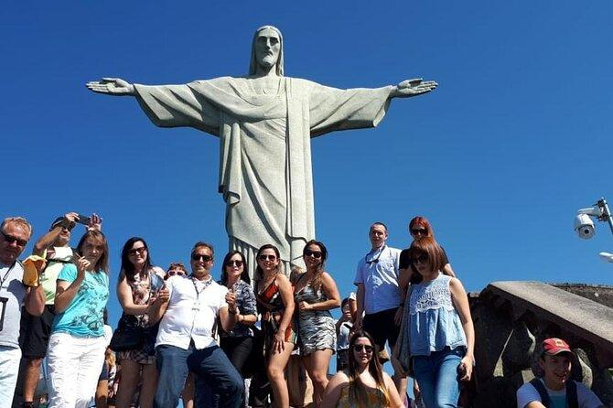

Dinner at Rio Escenarium famous for the dances and nightlife- 110 U$/person

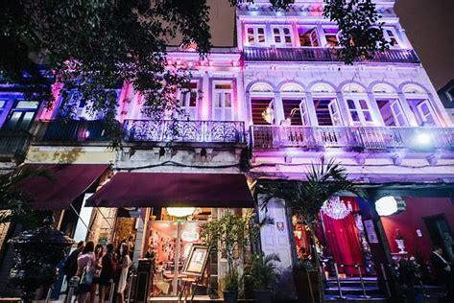
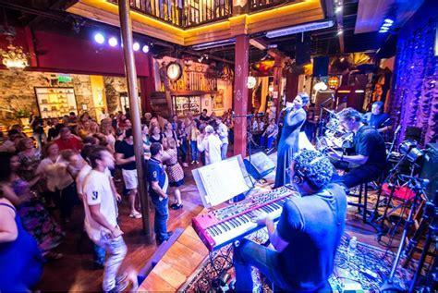

Day 3 Congress in the morning after breakfast

In the afternoon you have the chance to go on a half-day excursion to the Sugarloaf. The first stop is the Urca Mountain, with a wide viewing area that also offers the possibility to have a snack in the restaurant on top of the mountain. On the mountain of Sugar Loaf you will have a beautiful view of Rio, Copacabana beach, the bay, the surrounding mountains, islands in the ocean, bridge Niteroi, and the statue of Christ on Corcovado Mountain. After going down by cable car, the tour continues and we set off on a tour through the city.
Lunch at Caix de Oriente. Tour with lunch 155 U$/person Speedacess tickets to sugerloaf supplement 50 U$/person
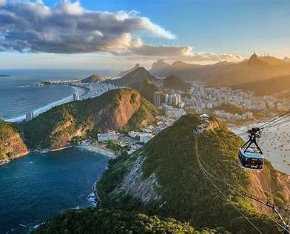
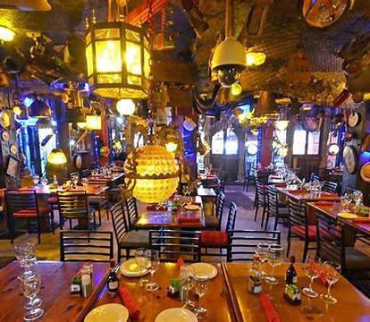
Dinner at Marius Seafood restaurant- Marius is a restaurant that looks like a sunk ship and inside has beautiful amethyst caves- 150 U$.person incl trasfers


Day 4
Congress after breakfast- Today we visit the Tropical Tijuca rainforest by jeep OR cook in Rio adventure

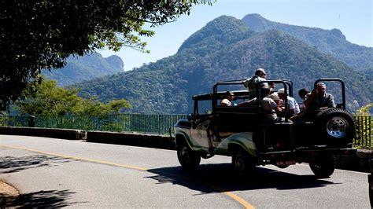

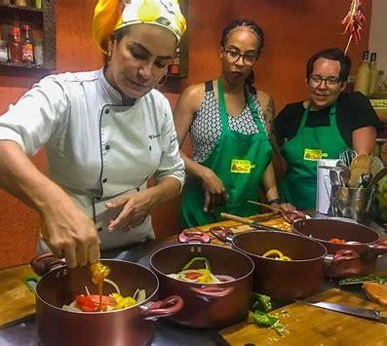

or a full day tour to the tropicals islands (about 3 hrs from Rio) and a boat ride there
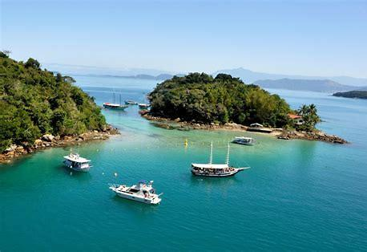

or a boat ride through the Rio de Janeiro bay
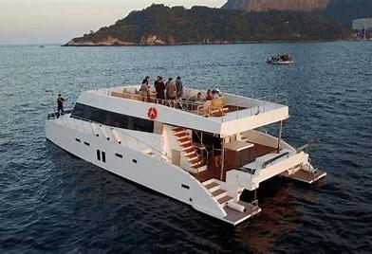

Lunch is planned in the Palace Grill restaurant or on the yacht.
Dinner is planned at the Assador Restaurant 140 U$/person incl transfers.

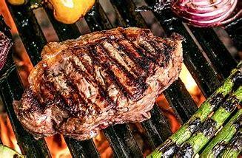

Day 5
After breakfast transfer out to the airport- 500 U$ per all

Meeting rooms (there are different options) start at 2700 U$/room/day
Coffee breaks start at 25-45 doll (different options)
Welcome reception at the hotels with drinks and finger foods can be starting from 65 U$ -110 $ per person (depending on what drinks are included)
a passat for driver full day at value of 450doll/day (8 hrs)

