Congress in Argentina- base 45 pax

Itinerary:

Day 1- Day 5 4 nights stay in hotel Palladium Buenos Aires 370 U$/room/night BB

Day 1 - Transfer in airport to Hotel – USD 575 per all
Arrival day in Buenos Aires! Our guide will be waiting for you at the international airport of Rio de Janeiro to transfer you to your hotel. The rest of the day is free to discover the city.

Welcome drink

Transfer to Dinner at La Cabaña Restaurant - Dinner and transfer at 80 $/person
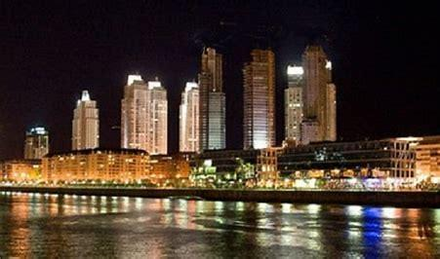

Day 2 - congress in the morning after breakfast
After the congress you have the chance to go on a half-day excursion around Buenos Aires city.
Discover the vibrant energy and rich history of Buenos Aires on this captivating 4-hour city tour. Begin your journey in the iconic Plaza de Mayo, where the historic Casa Rosada and the Metropolitan Cathedral stand as testaments to Argentina's past. Stroll through the charming streets of San Telmo, filled with antique shops and tango bars, before immersing yourself in the colorful spectacle of La Boca's Caminito street. Experience the grandeur of Recoleta Cemetery, final resting place of Eva Perón, and marvel at the intricate mausoleums. Conclude your adventure in the modern neighborhood of Puerto Madero, where sleek architecture meets waterfront views, offering a glimpse of Buenos Aires' dynamic present. With expert guides and comfortable transportation, this tour promises a memorable exploration of Argentina's captivating capital – 45 USD/person
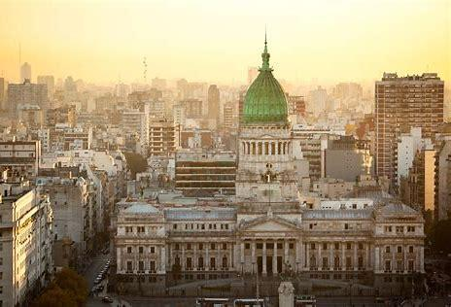
Dinner & Tango Show at Michelangelo Tango w/private transfers incl. - 120 U$/person

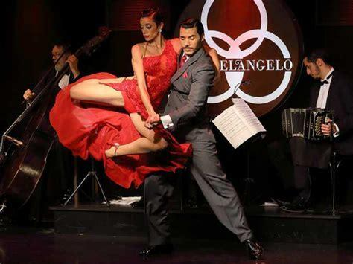
Day 3 - Congress in the morning after breakfast

Tour to Delta Tigre with navigation in private boat.
Escape the hustle and bustle of Buenos Aires with a tranquil excursion to the Tigre Delta. Departing from the city, embark on a scenic journey through the lush landscapes of the Paraná Delta. Cruise along the intricate waterways aboard a traditional boat, passing picturesque islands and charming riverside homes. Immerse yourself in the laid-back atmosphere as you explore the vibrant Tigre Market, where local artisans showcase their crafts and culinary delights. Admire the elegant architecture of the Tigre Art Museum and soak in the natural beauty of the delta's serene surroundings. With opportunities for leisurely walks, boat rides, and cultural discoveries, this excursion offers a refreshing retreat from the urban landscape of Buenos Aires. – 70 USD/person

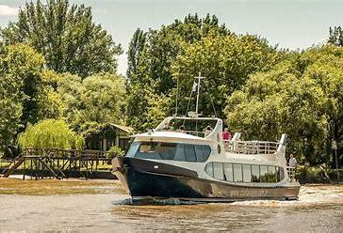
Dinner at Piegari Carnes Italian Restaurant – Diamond menu - 98 U$.person incl transfers.

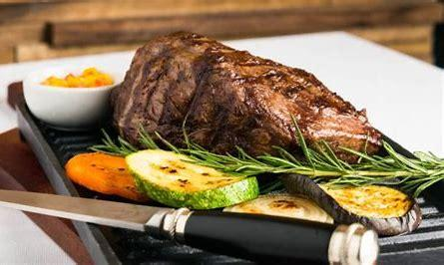
Day 4 - Congress after breakfast

Dinner is planned at the Fervor Restaurant - 90 USD/person incl transfers
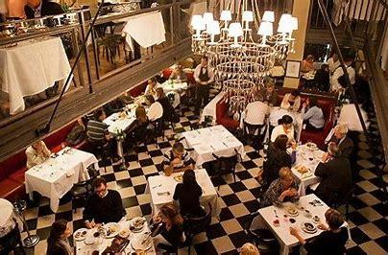
Day 5
After breakfast transfer out to the airport- 575 U$ per all
========================================================================

Meeting rooms (there are different options) start at 3200 U$/room/day - PENDING
Coffee breaks start at 25-45 doll (different options) - PENDING
Welcome reception at the hotels with drinks and finger foods can be starting from 65 U$ -110 $ per person (depending on what drinks are included)
a Sedan (Passat or similar) for driver full day at value of 250 USD/day (8 hrs)

