Dreams Come True
Rio de Janeiro (3n) + Foz do Iguacu (2n) + Buenos Aires (3n)
9 days/ 8 nights
Dreams Come True 2025
3* Hotels: Best Western Plus Design Copacabana (3N) + Viale Tower (2N) + Icaro Suites Buenos Aires (3N) | 1 Pax | 2 Pax |  | 3 Pax
 | SGL | SGL | DBL | SGL | DBL | TRL
 | $ 4,184 | $ 3,160 | $ 2,635 | $ 3,091 | $ 2,566 | $ 2,500
4* Hotels: Arena Leme (3N) + Vivaz Cataratas (2N) + 474 Buenos Aires (3N) | 1 Pax | 2 Pax |  | 3 Pax
 | SGL | SGL | DBL | SGL | DBL | TRL
 | $ 4,696 | $ 3,673 | $ 2,904 | $ 3,604 | $ 2,835 | $ 2,691
5* Hotels: Miramar (3N) + Doubletree by Hilton Foz (2N) +lntercontinenetal Buenos Aires (3N) | 1 Pax | 2 Pax |  | 3 Pax
 | SGL | SGL | DBL | SGL | DBL | TRL
 | $ 5,996 | $ 4,973 | $ 3,641 | $ 4,904 | $ 3,573 | $ 3,233

Days of arrivals
06.01.2025 | 07.06.2025
12.01.2025 | 21.06.2025
25.01.2025 | 05.07.2025
01.02.2025 | 19.07.2025
08.02.2025 | 02.08.2025
15.03.2025 | 16.08.2025
29.03.2025 | 30.08.2025
05.04.2025 | 27.09.2025
26.04.2025 | 18.10.2025
05.05.2025 | 08.11.2025
17.05.2025 | 06.12.2025

A trip through the magnificent Rio de Janeiro, combined with the Iguassu Falls and Buenos Aires. You will see green hills, blue sky, rocky mountain and beautiful beaches in Brazil, while seeing the world widest falls the next day. Your trip ends in Argentina where you can dance the Tango and enjoy the Argentinean way of life!

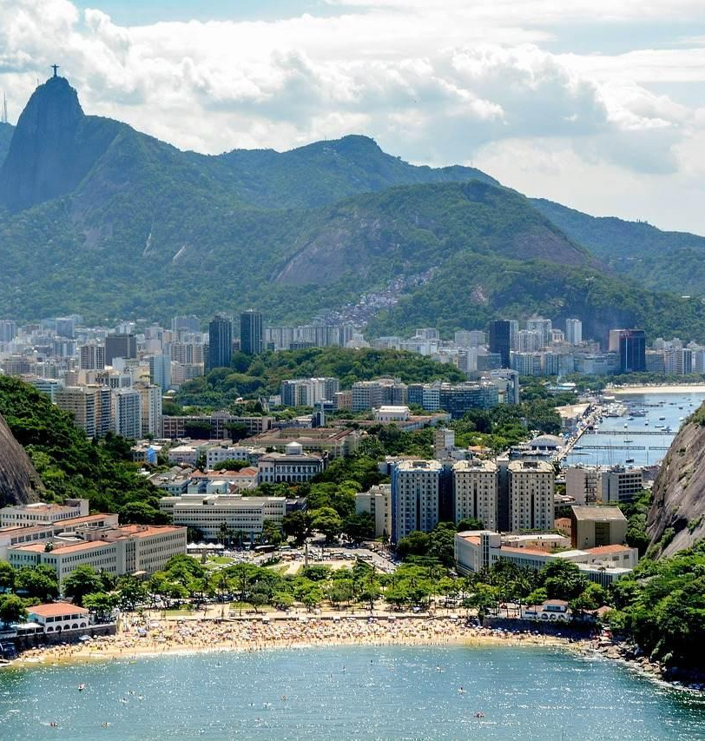
Day 1. Rio de Janeiro
Take in the breathtaking view as your plane descends upon Rio de Janeiro – the 'Marvelous City' where rolling green hills, turquoise ocean, sandy beaches and high-rise urban development is all packed together in a unique blend of life and humanity. Your driver will take you from the airport to the hotel, during which time you can get a different perspective of the city, passing through the colonial style buildings and along the world-famous beachfront. The natural beauty of Rio is almost transcendental and gives you a taste of the Amazon rainforest while still retaining everything that is so incredible about a Latin American city. A walk along the mosaic tiles of Copacabana reveals much about the life of a 'carioca' (Rio local) – a refreshing caipirinha as the waves lap against the shore, a fiercely competitive game of foot volleyball, and thousands of beachgoers sunning themselves on the white sands. You have truly arrived in paradise.

Day 2. Rio de Janeiro
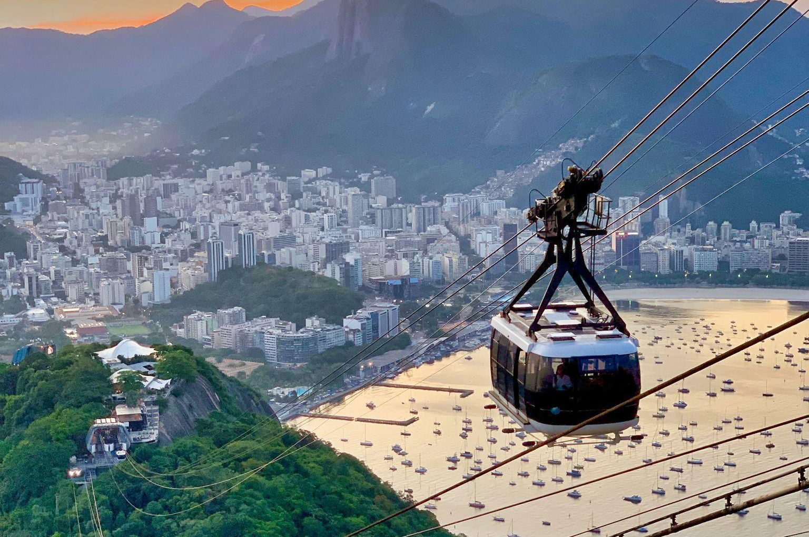
After breakfast in your hotel you will be taken to the mythical Sugarloaf mountain, protruding abruptly from out of the ground like an asteroid just fallen from space. A magnificent cable car ride will take you up to Urca Mountain, the stop off between ground level and Sugarloaf. From there you can enjoy a smooth cocktail or sample some of Brazil’s many signature dishes. Once arriving at the top of Sugarloaf mountain you will see the captivating beauty of Rio from a different angle, To your left you can see Copacabana beach stretching off into the distance, and on the horizon the faint outlines of Two Brothers and Gávea mountains. Below you is the quaint and intimate Red Beach, while to your right you can see across Guanabara Bay to Niterói and, closer in, Rio’s Botafogo and central neighborhoods, with the unmistakable silhouette of Christ the Saviour casting its eternal gaze over the city. This trip is essential to gain a different perspective on Rio, and to truly understand its beauty.
After descending the mountain by cable car, you will head into the Old Town and Centre, where colonial architecture still remains and many old churches such as the Candelária are still in use. The cobbled streets and bright colors are a stark contrast to the whitewashed, sunsoaked streets of Ipanema but in many ways are part of the authentic, nearly-forgotten Rio of old, and one can almost feel the hustle and bustle of hundreds of years ago when these streets were filled with merchants and citizens of the Portuguese Empire.

Day 3. Rio de Janeiro
Tour to Corcovado Mountain + Christ the Redeemer Statue
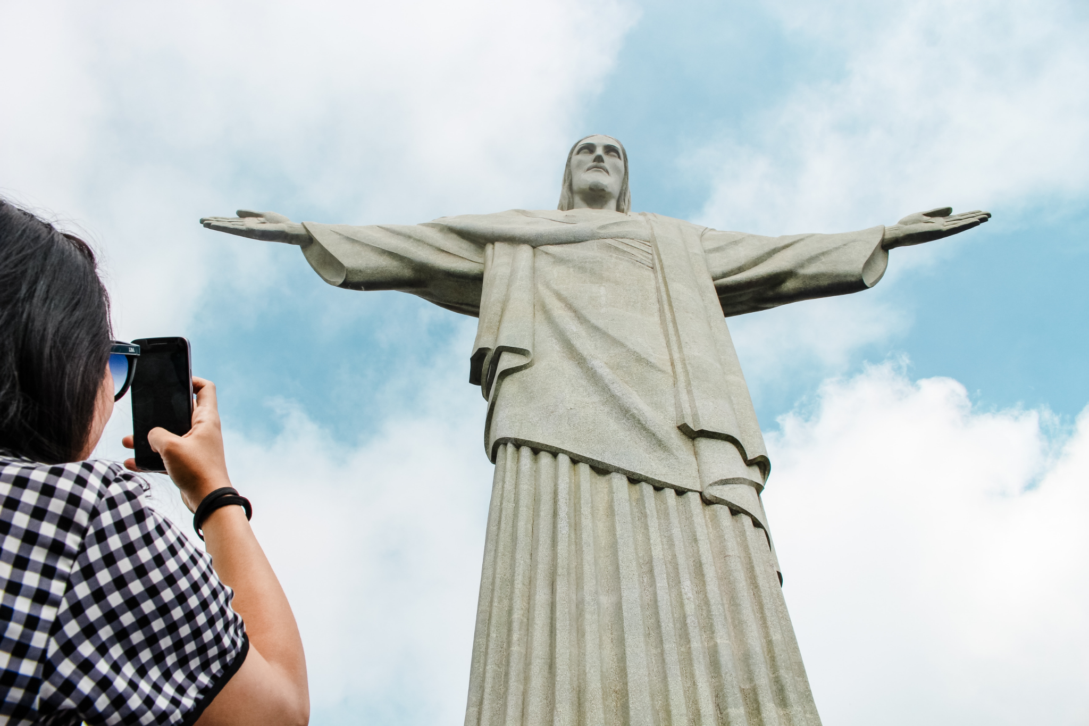
After a delicious tropical breakfast in your hotel, you will head out on a trip to see the world-famous Christ the Saviour statue on top of Corcovado Mountain. A specially designed train will take you from the foot of the mountain along a winding road through the magical Tijuca rainforest where you will see some of the enchanting tropical wildlife on constant display in Rio, such as toucans, monkeys and armadillos. At the summit of Corcovado, 700m above sea level, proudly stands the iconic image seen around the world – a 38m high statue of Christ the Saviour. But that is not the only breathtaking thing about this place – when up close to the statue you will be overwhelmed by the stunning panoramic view of the city, so high up it seems as though you are truly flying with the birds around you. From the far reaches of Guanabara Bay, to the Maracanã Stadium, all along to Sugarloaf Mountain, Copacabana, Ipanema and Gávea Mountain, you can see the whole of Rio de Janeiro.

Day 4. Rio de Janeiro – Foz do Iguacu
Transfer to the airport with a driver only. Flight to Foz do Iguacu. Arrival in Foz do Iguacu airport. Meeting at the airport with your driver.

Day 5. Foz do Iguacu
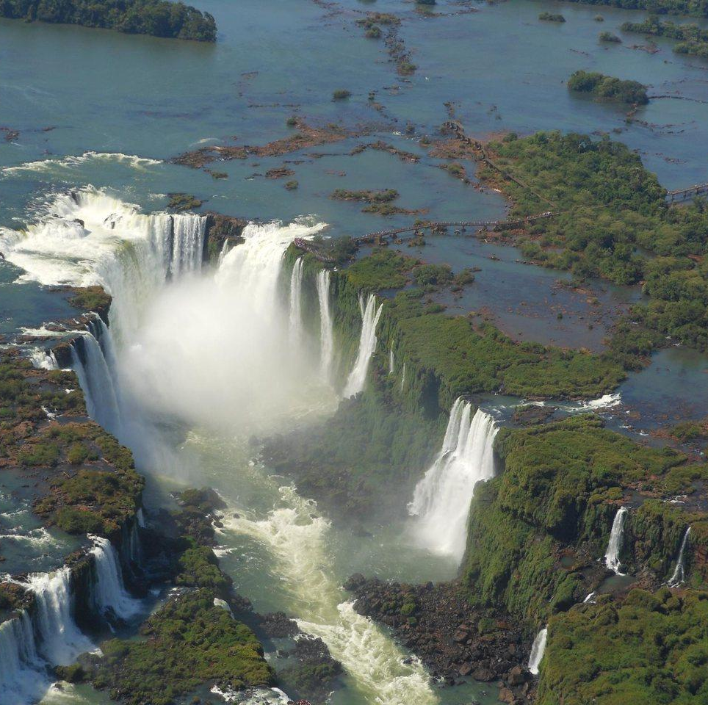
After breakfast you will have an excursion to the Brazilian side of the falls. A tranquil and calming walk along the edge of the falls provides the most spectacular view you have ever seen; over 250 overflowing with millions of gallons of water racing furiously down straight from the Amazon River. The sunlight flashing off the water has the mesmerizing effect of creating hundreds of rainbows as far as the eye can see. It is almost hard to believe, such is the breathtaking beauty of the rainforest paradise. After taking in the incredible views, the path takes you to the eye of the storm, the largest waterfall in the park, The Devil’s Throat. Water crashes off an 80m cliff edge into the Iguazu River, but you have the chance to meet the water via a walkway that leads you into the heart of the waterfall. Feel the power of the water as it surrounds you from all sides, before heading up a stairway to look down from above on the mother of all waterfalls. At the end of the tour, your guide will drop you off at your hotel (entrance ticket included).

Day 6. Foz do Iguacu – Buenos Aires
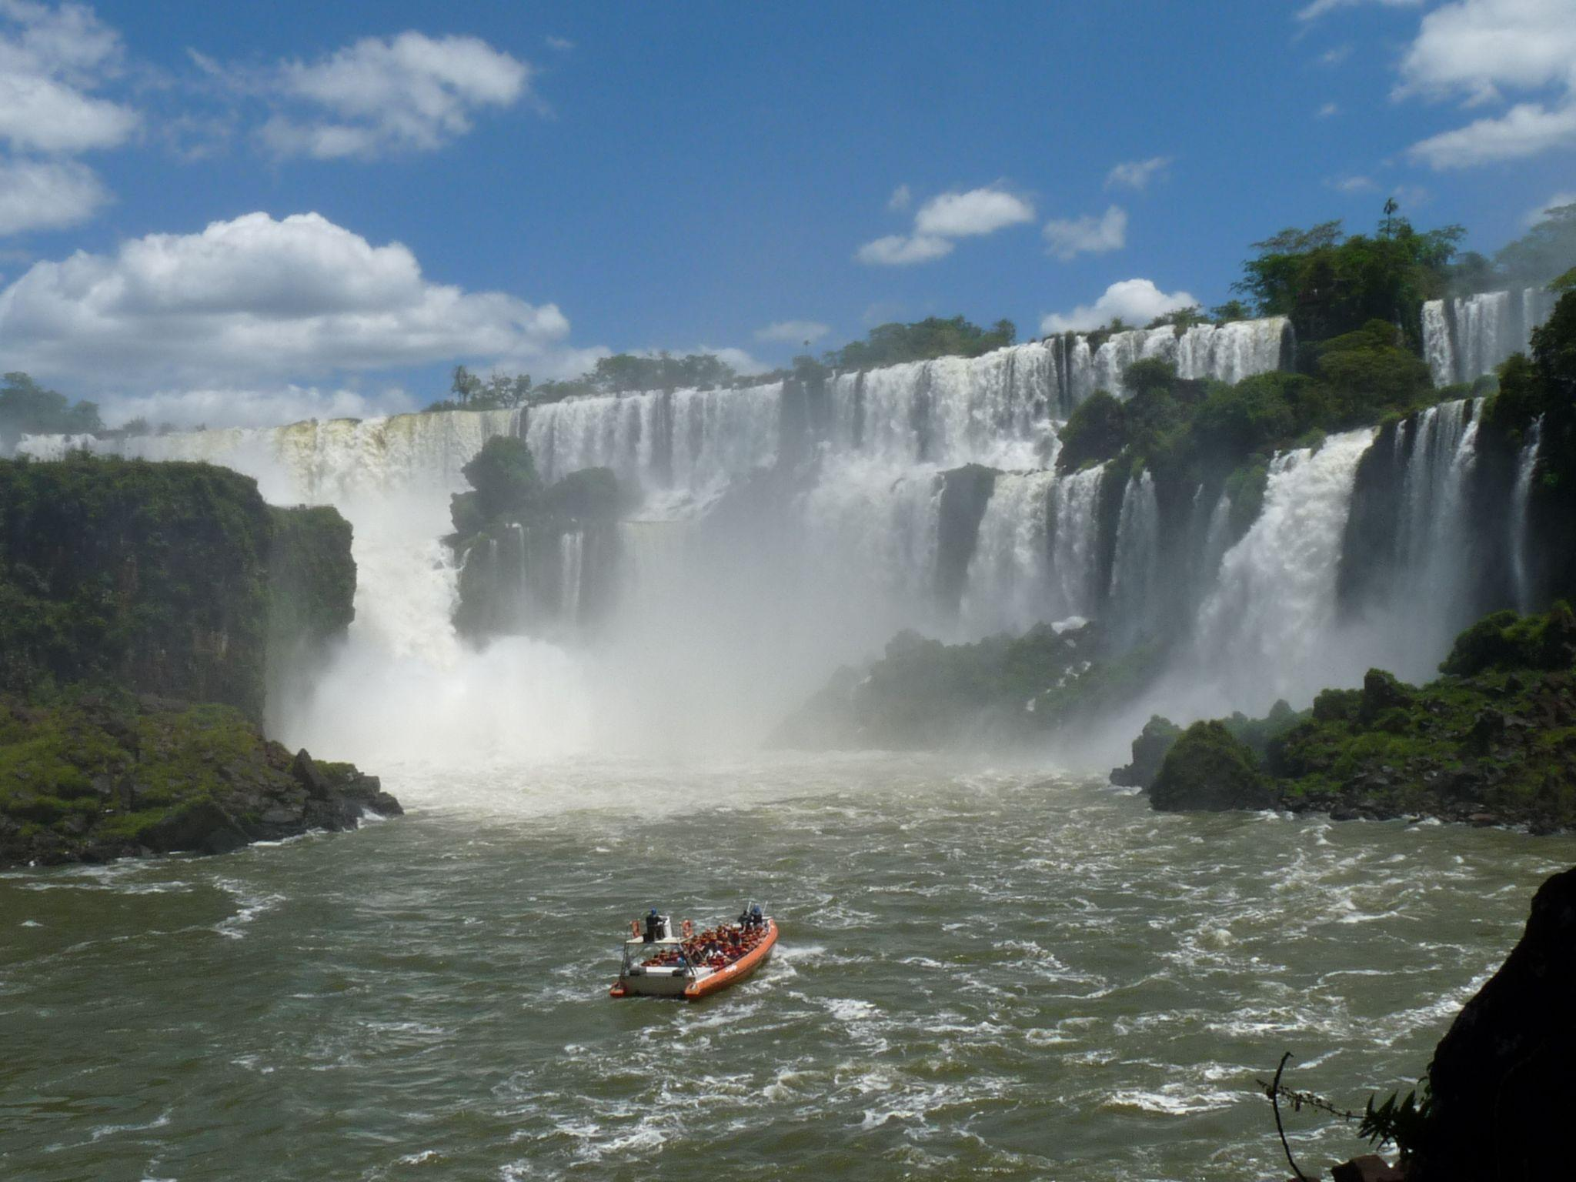
After breakfast you will go to the Argentinian side of Waterfall. The Argentinean side is different from the Brazilian; you will walk on paths through the falls which give you the opportunity to have a look under the falls. You feel the strength of the falling water from up close and enjoy the 55.500 hectares natural park surrounding this spectacular beauty! Within the park, take the train to the marvelous devil's throat the strongest of all the waterfalls. Stand directly above the falling water and admire the strength of this natural phenomenon.
After that you will be transferred to the airport for your flight to Buenos Aires. Arrival in Buenos Aires. Transfer to the hotel in Buenos Aires. Accommodation and rest in the hotel.

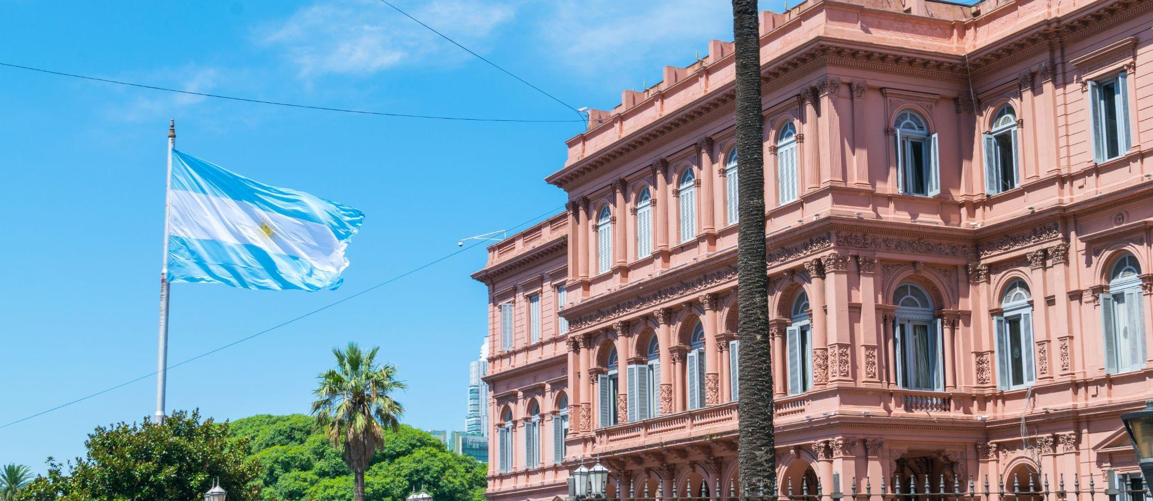
Day 7. Buenos Aires
After breakfast, our guide will pick you up at your hotel for a half day city tour in Buenos Aires. This panoramic tour will take you through the highlights of South America's most European and cosmopolitan city. We'll drive along 9 de Julio Avenue where the renowned Colón Theater and the Obelisk, symbols of our city, are located. We'll visit Plaza de Mayo, surrounded by important historic buildings like the Casa Rosada, the Cathedral and the City Hall. We'll also visit Plaza San Martin, Alvear and Plaza del Congreso. The tour will drive us along the old fashion Avenida de Mayo and the dynamic Avenida Corrientes. Explore neighborhoods filled with colors and history, like La Boca and San Telmo, and the sumptuous neighborhoods of Palermo, Recoleta and the modern Puerto Madero, a busy gastronomic and entertainment area.
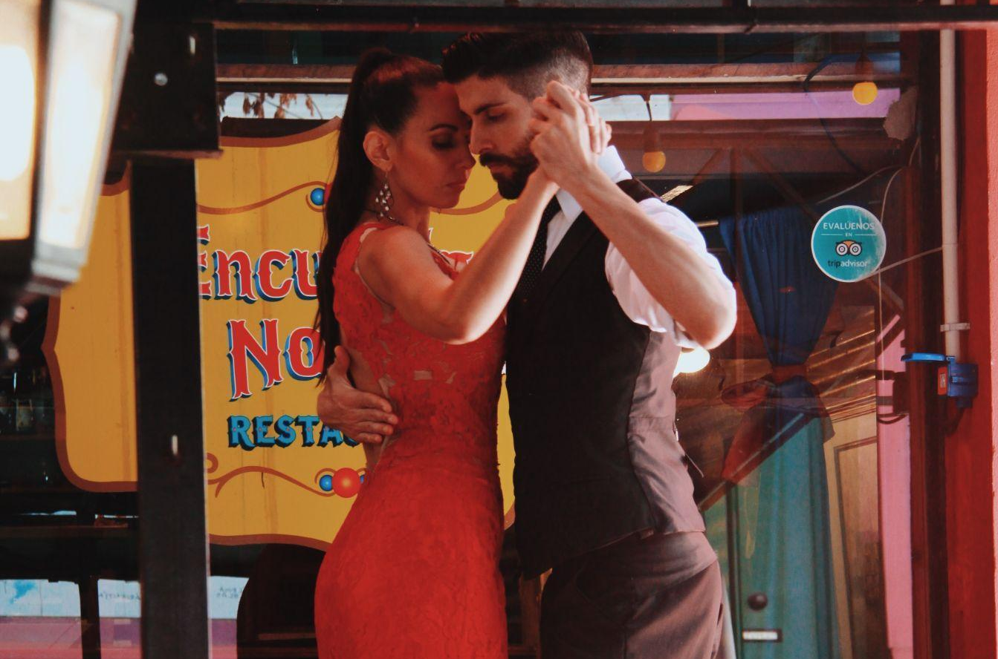
In the evening enjoy an amazing Tango Show and Dinner. Tango is still alive. A good way of penetrating its spirit is visiting one of the restaurants that offers tango shows of an excellent level, to enjoy tango´s sensual magnetism taken to the stage by some of the best dancers, singers and musicians in Buenos Aires! After a delicious dinner, you will follow a spectacular presentation of acclaimed popular and sensuous Tango, performed by the world's best. It is the music of Buenos Aires par excellence. Tango is felt in the air of the city, as humidity!

Day 8. Buenos Aires
Today you have the day free to enjoy the city as you want! Or take some optional tours.

Day 9. Buenos Aires
After breakfast at the hotel, you will be transferred to the international airport to take your departure flight on time.
Optional excursions:
In Rio de Janeiro
1) The Botanical Garden ( private tour min.2 pax USD 210 P/P)
The botanical garden was founded by Prince D. Joao VI in the beginning of the 19th century. Here you can find the famous Pau Brasil, the tree that gave Brazil its name. The botanical garden has around 7000 species of plants, amongst which the enormously high Imperial Palm trees. Also, some of the most exotic plants from the Amazon can be found in this garden such as the Vitoria Regia and the wild orchid.
2) Rio at night ! (USD 150 P/P) *(only show)
3) Guanabara Bay – boat trip! *group boat ( min. 2 pax ) with English speaking guide (USD 270 P/P)
You start sailing from the Marina Gloria port on a comfortable boat and enjoy the views of one of the largest and most beautiful bays in Brazil. Enjoy the sea breeze, the blue ocean and magnificent views of Rio. During this tour you will see the most picturesque and panoramic beauties of Rio de Janeiro. We are sailing past the famous areas of the city - Botafogo, Flamengo, and Urca. Even at a distance, the landmarks of Rio the Sugar Loaf, tropical islands, Fort San Joan, and the Rio Niteroi Bridge, the Niemeyer-designed Museum of Modern Art, the 16th-century Santa Cruz Fortress and favelas located on the slopes of the mountains - are impressive. Transfers are included.
4) Old Rio’s secrets 4 hours *private (min. 2 pax) with English speaking guide (USD 180 P/P)
5) Flying over Rio by Helicopter (price on request depending on flight duration ) You have the option to order a helicopter tour from the Sugarloaf mountain. During your flight you will get amazed by the mind-blowing view of the city below with its infinite beaches, huge Christ statue, Botanical Garden and many more. Duration: 6-13 minutes
6) Favela Tour! *(in SIB tour with an English speaking guide (USD 120 P/P)
Once, the soldiers from Bahia fought with the royal troop on the hill where the favela tree grew. After the war, the survivors came to Rio de Janeiro to demand payment. They settled on Providence Hill, and there they stayed to live. In memory of their battle, they named it the hill of the favela. Here, narrow dirty streets wind along which fetid ditches stretch. In total, there are 700 favelas in Rio. It's not just thieves and drug dealers who live in favelas. There are both technicians and employees here, and you can even rent a room. You can get here with the permission of the local godfather. The police don't come here. The favela has its own internal laws. You will ride around the Rocinha areas in a jeep and return to the hotel.
7) Hang gliding (USD 420 P/P) You will be taken by a guide to the Tijuca forest, to the Pedra Bonita Mountain (a beautiful stone). Pedra Bonita offers a full view of Rio de Janeiro. Flying over the green slope of the mountain and the endless ocean gives a great doze of adrenaline! A professional English-speaking instructor will give you all the safety instructions and explain all the necessary methods for jumping. You will be dressed in full ammunition and after several imitations of jumping, you run up and jump together with the instructor. After flying over the sea, you will get to Pepino Beach. Transfers and recording gopro cameras are included.
Iguazu
1) Rafain show (USD 120 P/P)*drinks are not included
Rafain Grill Place is a huge restaurant with 1200 seats with air conditioning and parking. The restaurant's menu is very diverse and you can try a variety of meat dishes made from the freshest beef and pork. The buffet is rich in vegetables, fruits and a delicious dessert. The lunch is accompanied by a show of Latin American artists who present both folklore chants and modern dances.
2) Bird park (Price USD 75 P/p)
One of the city's most important tourist attractions, the Parque das Aves is located next to the entrance of the Iguaçu National Park. Inside the Parque das Aves you will be in a unique universe, surrounded by birds from all over Brazil and the world. There are more than 800 birds from 200 different species preserved in 16.5 hectares of spectacular Atlantic Rainforest in which you can walk with your friends and family when visiting Foz do Iguassu. The Parque das Aves has three immersion aviaries and a butterfly house, in which you can enter and be side by side with toucans, scarlet ibises, macaws, jays and thrushes. Over the course of this extraordinary tour you'll also find harpy eagles, owls, parrots and even reptiles such as alligators and the anaconda. By the end, you can relax in the restaurant with an exclusive view across the lake of flamingos or take as a souvenir a picture holding a macaw or next to a boa constrictor. Have the best experience with the natural world of Foz do Iguaçu and bring your friends and family to the Parque das Aves for an unforgettable adventure
3) Macuco Safari (Price USD 130 P/p)
The big adventure begins at the Macuco Safari entrance gates, located at kilometer 25 of the Cataratas Highway inside the Iguassu National Park, with embarkation in open jeep-towed wagons that permit an unobstructed view of the scenery along the trail. During the stretch of three kilometers through the jungle, multilingual guides point out examples of the flora and fauna of the Park. Orchids, palm trees, bromeliads, centenaria trees, as well as wild animals that occasionally cross the trail are pointed out by the guides. The hike - The second stage, a stretch of 600 meters (optional), is a hike on a trail that leads to a waterfall baptized "Macuco Falls". The waterfall - perfect for a refreshing dip on days of intense heat - spills down from a height of approximately 20 meters. Access is via a stairway carved into the ancient rock. The last stop is the Macuco Safari docks on the Brazilian side of the Iguassu River. In the water, inflatable bi-motor boats, constructed to withstand the rigors of the excursion, are secure and efficient vessels. Before embarkation, passengers receive life-vests and plastic containers in which to protect photographic and filming equipment. The boat travels up-river passing the canyon facing the rapids at a speed that permits the appreciation of the scenery. Rocks, animals and a lot of greenery completes the scenery until the base of the Falls is reached, next to the "great horseshoe" know as the "Devil's Throat". Waterfall shower - Rainbows, blue sky, mist and water in profusion, punctuate the spectacle that has as its high-point the area of the Falls baptized "The Three Musketeers". There the captain maneuvers the boat in order to get close enough to provide the passengers with a quick and refreshing shower
4) Flying over the Iguazu Waterfalls by helicopter *in addition to an excursion to the Brazilian side of Iguazu waterfalls (USD 230 P/P) minimum 3 people
You will see the power and beauty of waterfalls from a bird's-eye view! This is an amazing and unforgettable sight! Duration: 10 minutes
Buenos Aires
1) Tigre Tour and Northern Zone( SIB with English guide USD 140 P/P)
We will leave Buenos Aires city heading for the town of Tigre, one hour away, where we will board a tourist boat to navigate along the Delta and its islands. The life of the isleños (people who live on the islands of the Delta) is very special. We will learn about their customs, culture and ways of life. On the way back to Buenos Aires city we will drive by the elegant residences of the well-off, located in the northern suburbs, and the San Isidro neighborhood. Additionally, you will also get a glimpse of the Presidential Residence (Quinta de Olivos) as we drive by it.
2) Full day tour in Montevideo from Buenos Aires (SIB with English guide / USD 560P/P)
(Private excursion min.2 pax . USD 850 P/P)
A driver will take you to the port of Buenos Aires, where you will pick up a ferry boat to Montevideo city by Colonia del Sacramento. Upon arrival at Montevideo, a guide will be waiting for you for a panoramic city tour. This walk covers the most important points of the city's Old Town and new residential neighborhoods. Inside the old city is visited: Independence Square, where the old Citadel Gate (Montevideo was a fortified city), then comes Matrix Square where the Montevideo Cathedral, The Cabildo, Plaza Zabala and Teatro Solis, all these pieces of history of the city. Then its the Palacio Salvo, first high-rise building in the city, Plaza de El Entrevero, continuing to the Legislative Palace where the Uruguayan Parliament meets. The tour continues visiting the following suburbs: The Prado, with its ancient history which houses the Government House, the Parque Batlle, which runs the Estadio Centenario, La Carreta Monument and the residential neighborhoods of Carrasco and Pocitos. The return is by the coast to the center of Montevideo. At the end of the tour, you will get back to port to take a ferry boat back to Buenos Aires. Upon arrival, only a driver will take you to your hotel.
3) Day Ranch and Fiesta Gaucha in Santa Susana Ranch. (SIB with English guide USD 250 P/P)
Escape the city and journey back to simpler times with this Gaucho Party tour. Let us pick you up and transport you to an 'estancia' or ranch for a fun filled day.
Once we arrive at the estancia, Santa Susana, we’ll have some time to get to better acquainted with one another while indulging in handmade empanadas. After which, we will have some free time to take in the sights, explore the area, go horseback riding etc. The grounds are literally at your disposal.
You won’t have to worry about going hungry on this tour. After our free time we will be invited to partake in an 'asado', which is a traditional Argentinean barbeque that includes – both alcoholic and non-alcoholic drinks, and dessert with coffee or tea. The fun doesn’t stop there; after lunch we will be treated to both a folkloric and a tango show.
The cultural experience doesn’t end there. The real show will start when the gauchos come out to show you their skills. They will demonstrate ring-races, horse mildness among many others. This part of the day is also interactive, so you better have your boots on and ready to go.
Once we have said goodbye we will hop back on our comfortable and air conditioned bus for a relaxing trip back to Buenos Aires.
Itinerary
11:00 am - Reception with handmade empanadas and wine at the ranch's pulperia (traditional argentine bar).
11:30 am - Free activities. Walk around the beautiful garden, visit the local museum and church, go horseback riding or try the typical carriages.
1:00 pm - Lunch Time. Traditional Argentine barbecue with salads.Your choice of drinks includes soft drinks, beer, and red or white wine. For dessert taste traditional pastries accompanied with coffee or tea. Enjoy a lively folklore show with traditional singing and dancing as well as tango.
3:00pm - The gauchos will show you their skills such as ring-races, horse mildness, and troops retail-trade including the participation of the public.
4:30pm - Return to Buenos Aires

END OF SERVICES.

Prices include:
- Accommodation to suggested hotels on program or similar;
- Excursions described on program with English speaking guide;
- All transfers airports/ hotels/ airports with Driver only.
- Domestic flights Rio de Janeiro – Foz do Iguacu – Buenos Aires

Prices don’t include:
- Optional excursions;
- Meals & beverages not mentioned;
- International flight;

