08 Days. HIDDEN LAOS
Day 01. Bokeo-Luang Namtha(L/D)
Welcome the clients at the Lao-Thai friendship at Bokeo province. Take a drive by a/c bus to Luang Namtha province. Visit Lantan hill tribe villages and That Luang stupa stup
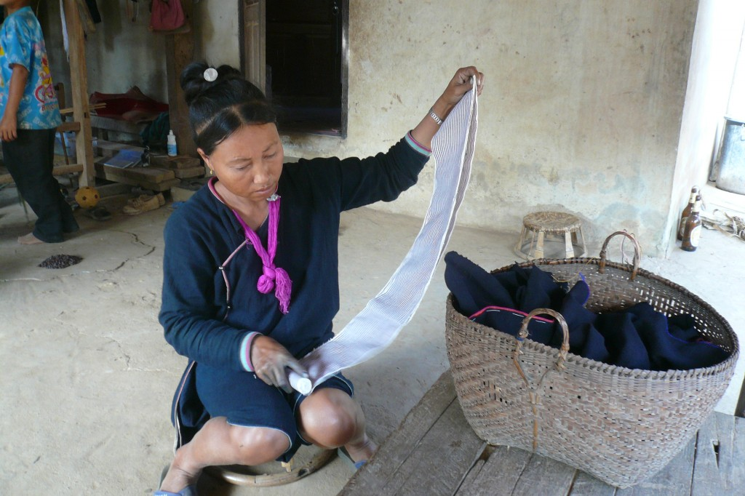
Day 02. Luang Namtha-Muangkhoa(B/L/D)
By road to Muang Khoa small villages located by the Nam Ou river, visit Taidam market, Wat Singkham temple at Muang La.
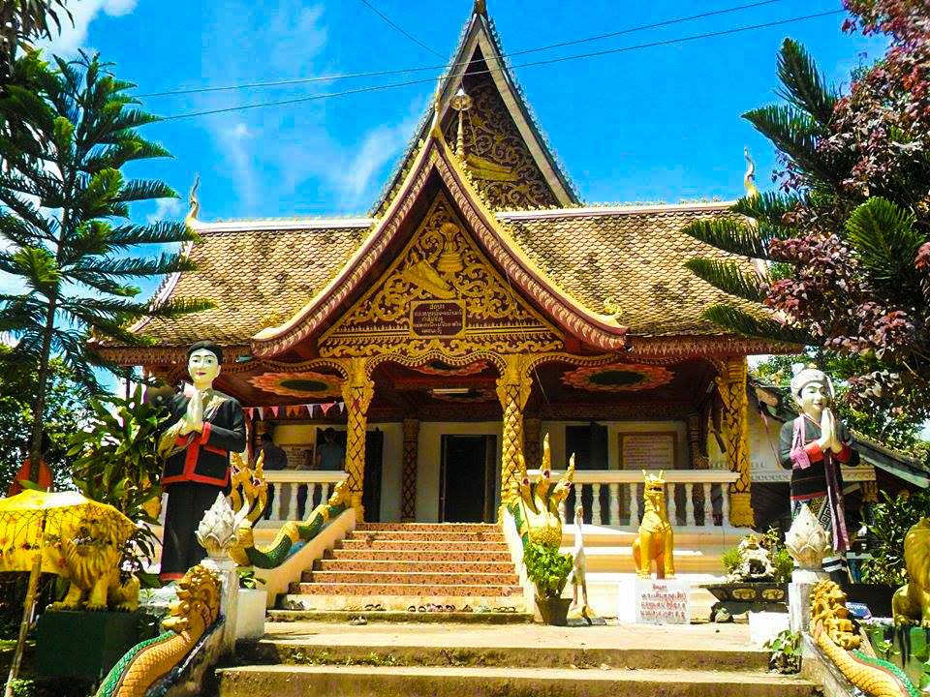
Day 03. Muangkhoa(B/L/D)
Take a drive to Ban Pak Namnoy to visit sticky rice alcohol distillation villages, and hike up the mountain to Ban Houypod the Akha Pouly hill tribe villages
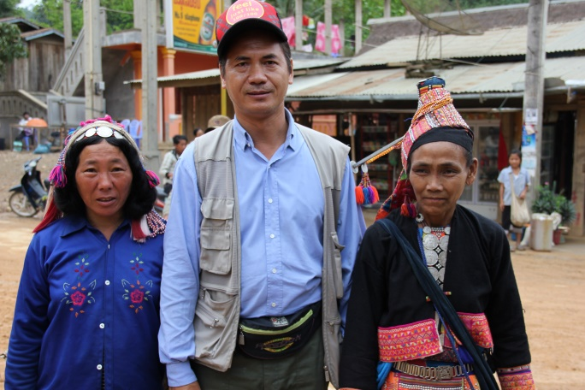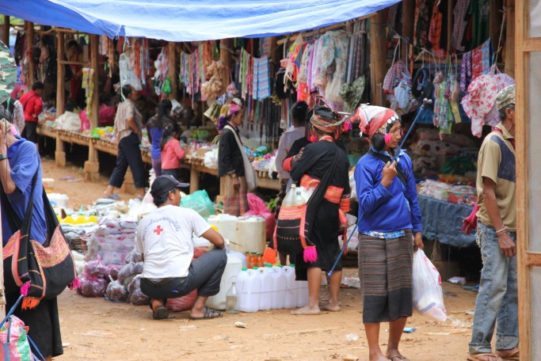

Day 04. Muangkhoa-Nongkhiaw(B/L/D)
Enjoy local long tail boat on the Nam Ou river one one of the most beautiful river in Laos to Nongkhiaw the small charming villages surrounded by rivers and mountains. Visit Ban Sopcham the taileu tribe villages
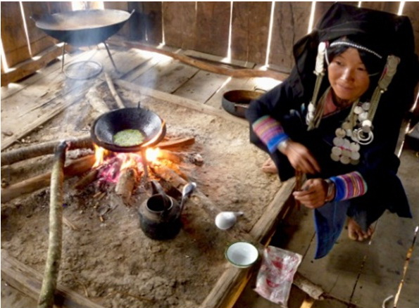
Day 05. Nongkhiaw(B/L/D)
Visit Tam Phatok cave, Tam Phakuang cave both are communist army caves during Vietnam war, and climb up to the mountain for the village view point
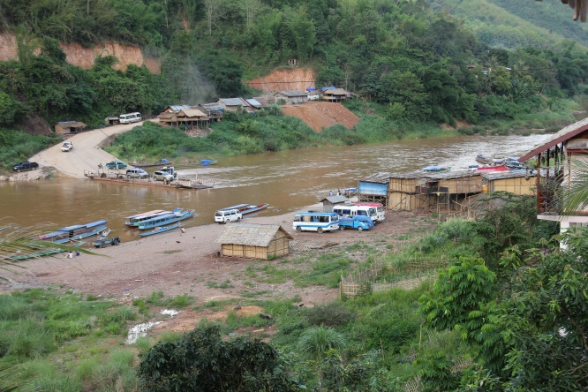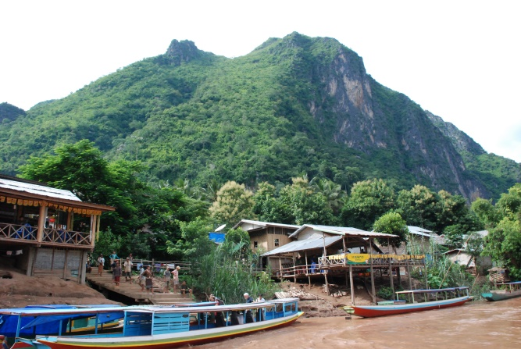
Day 06. Nongkhiaw-Luang Prabang(B/L/D)
Take a drive to Luang Prabang. Have lunch, afternoon visit Wat Xienghong, Wat Visoun and Phusi hill for sunset. Visit night market

Day 07. Luang Prabang(B/L/D)
Rise early this morning to witness and partake in the daily morning ritual of ‘Tak Bat’ or giving alms to the monks. This is a unique ritual still followed by the locals in Luang Prabang. We can also visit the local fresh market to see how the locals shop. After breakfast, visit Wat Mai temple. Take a long tail boat on the Mekong River to visit Pak Ou holly cave and Ban Sanghai villages
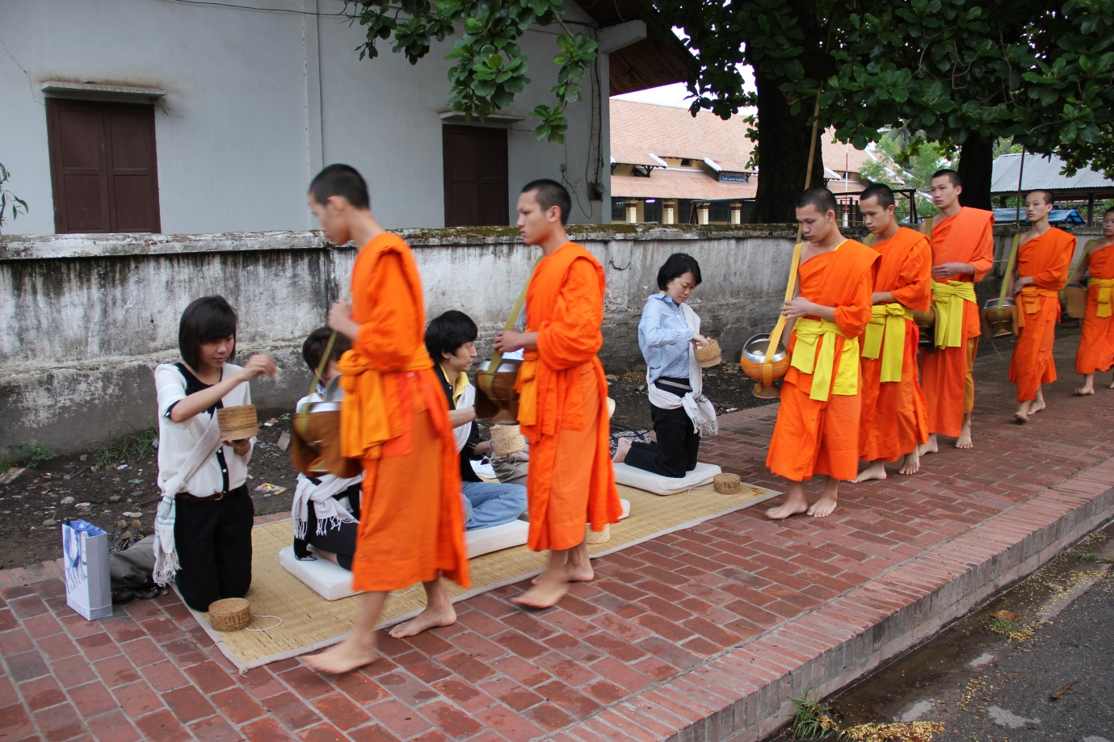
Day 08. Luang Prabang-Depart(B/L)
Visit the beautiful Kuang Si Waterfall, upon reaching the you can be enjoyed scenic water fall from the different points. After that you can have swim in the crystal care water or you can deep your leg and enjoy the sound of the water fall and birds chipping in the surrounding jungle, the bear rescue center. Visit former royal palace. Transfer to Luang Prabang international airport for departure

